Introduction to Multimedia Technology HW03 - CSIE 4B 408410120 鍾博丞

# Environment Requirements

* Optimization Toolbox – for linprog in emd.
* Parallel Computing Toolbox – for parfor.

# Reference

* <https://www.mathworks.com/matlabcentral/fileexchange/22962-the-earth-mover-s-distance>
* ChatGPT

# Time Domain Analysis

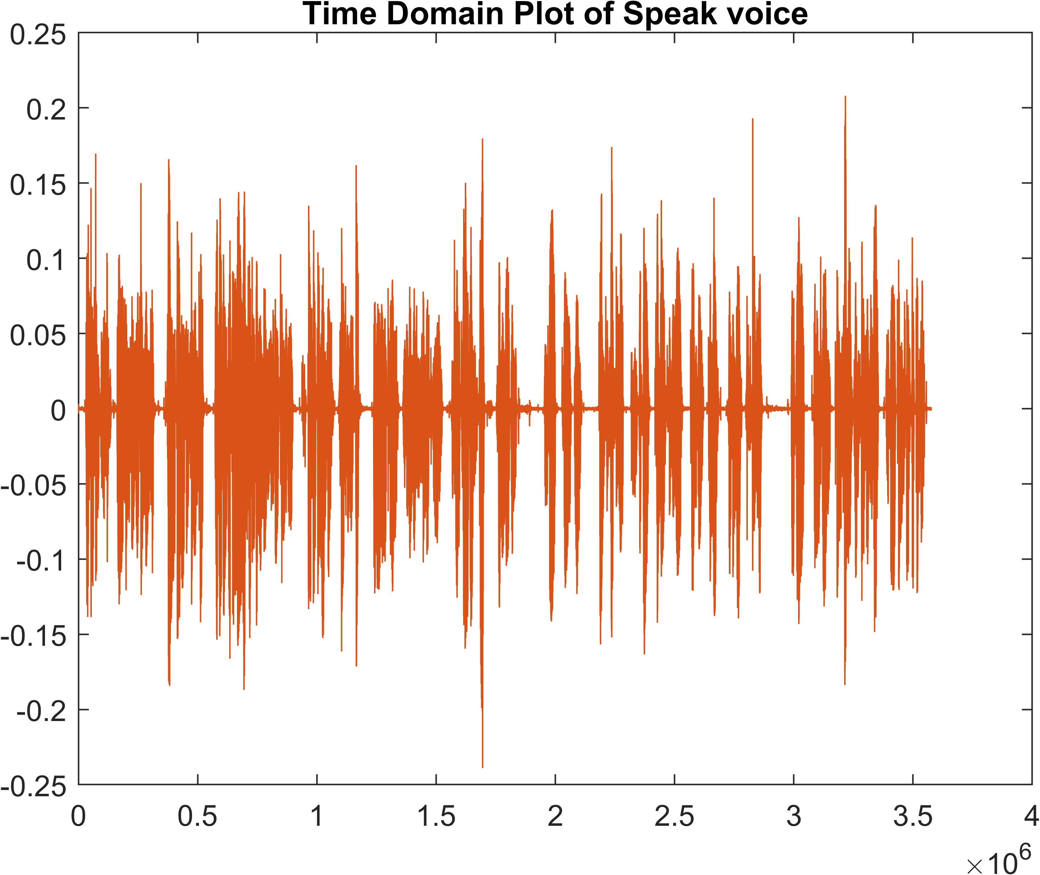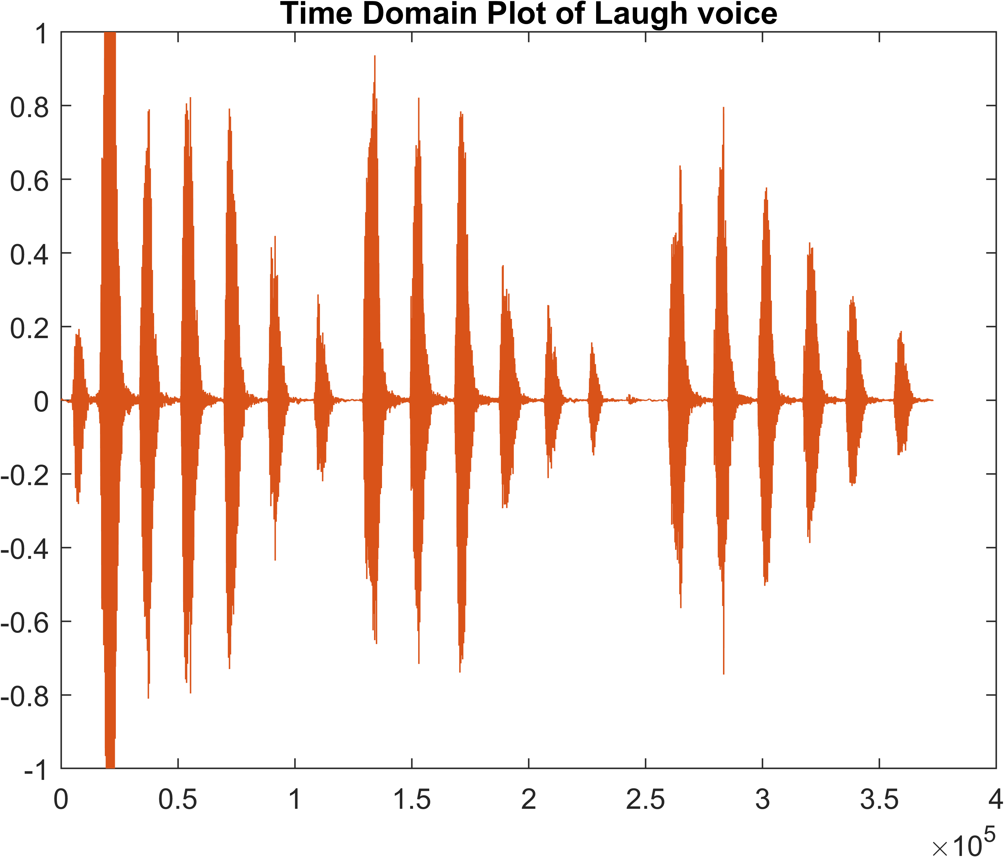

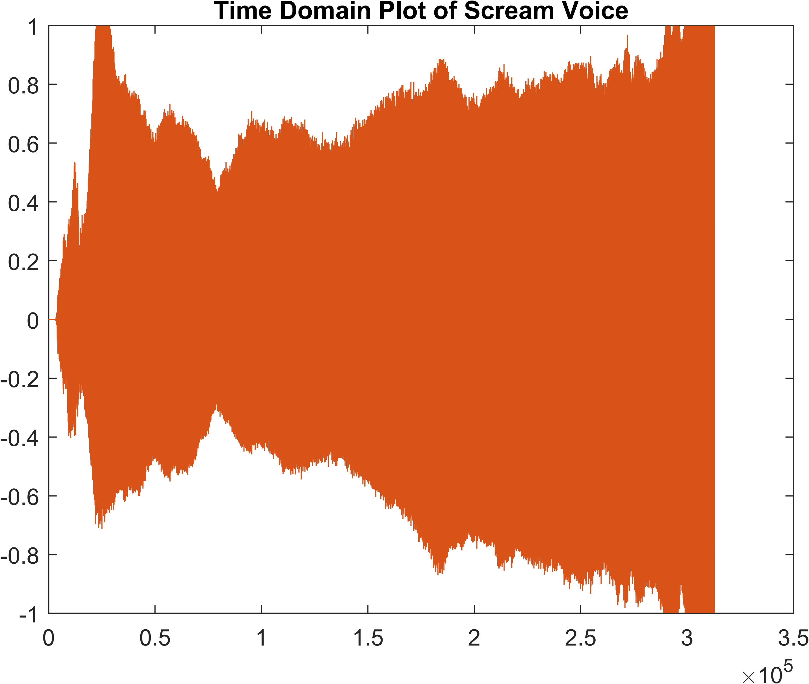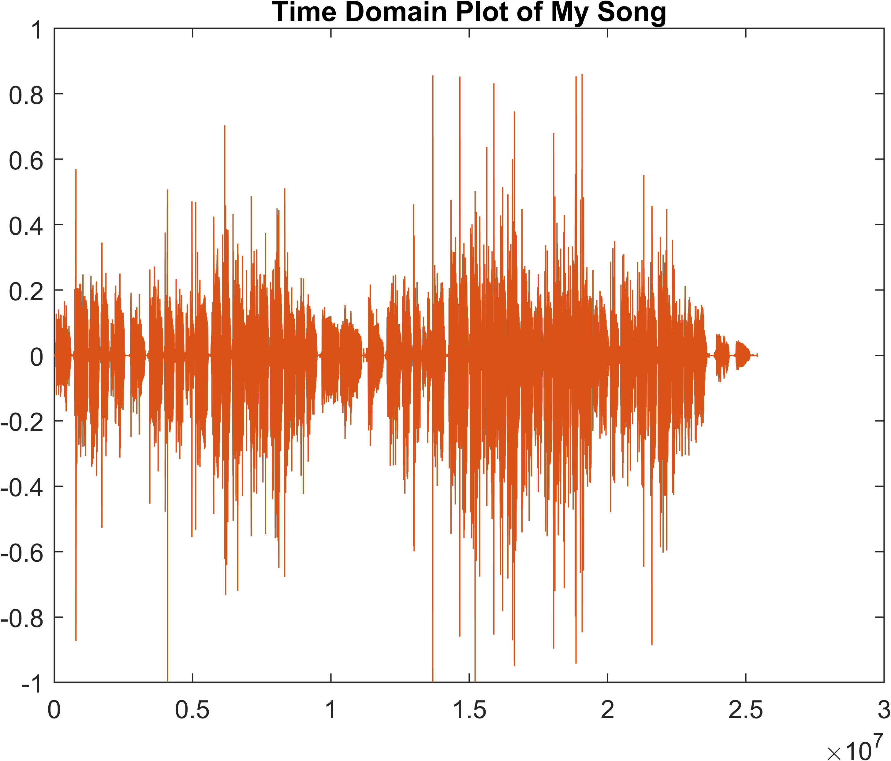

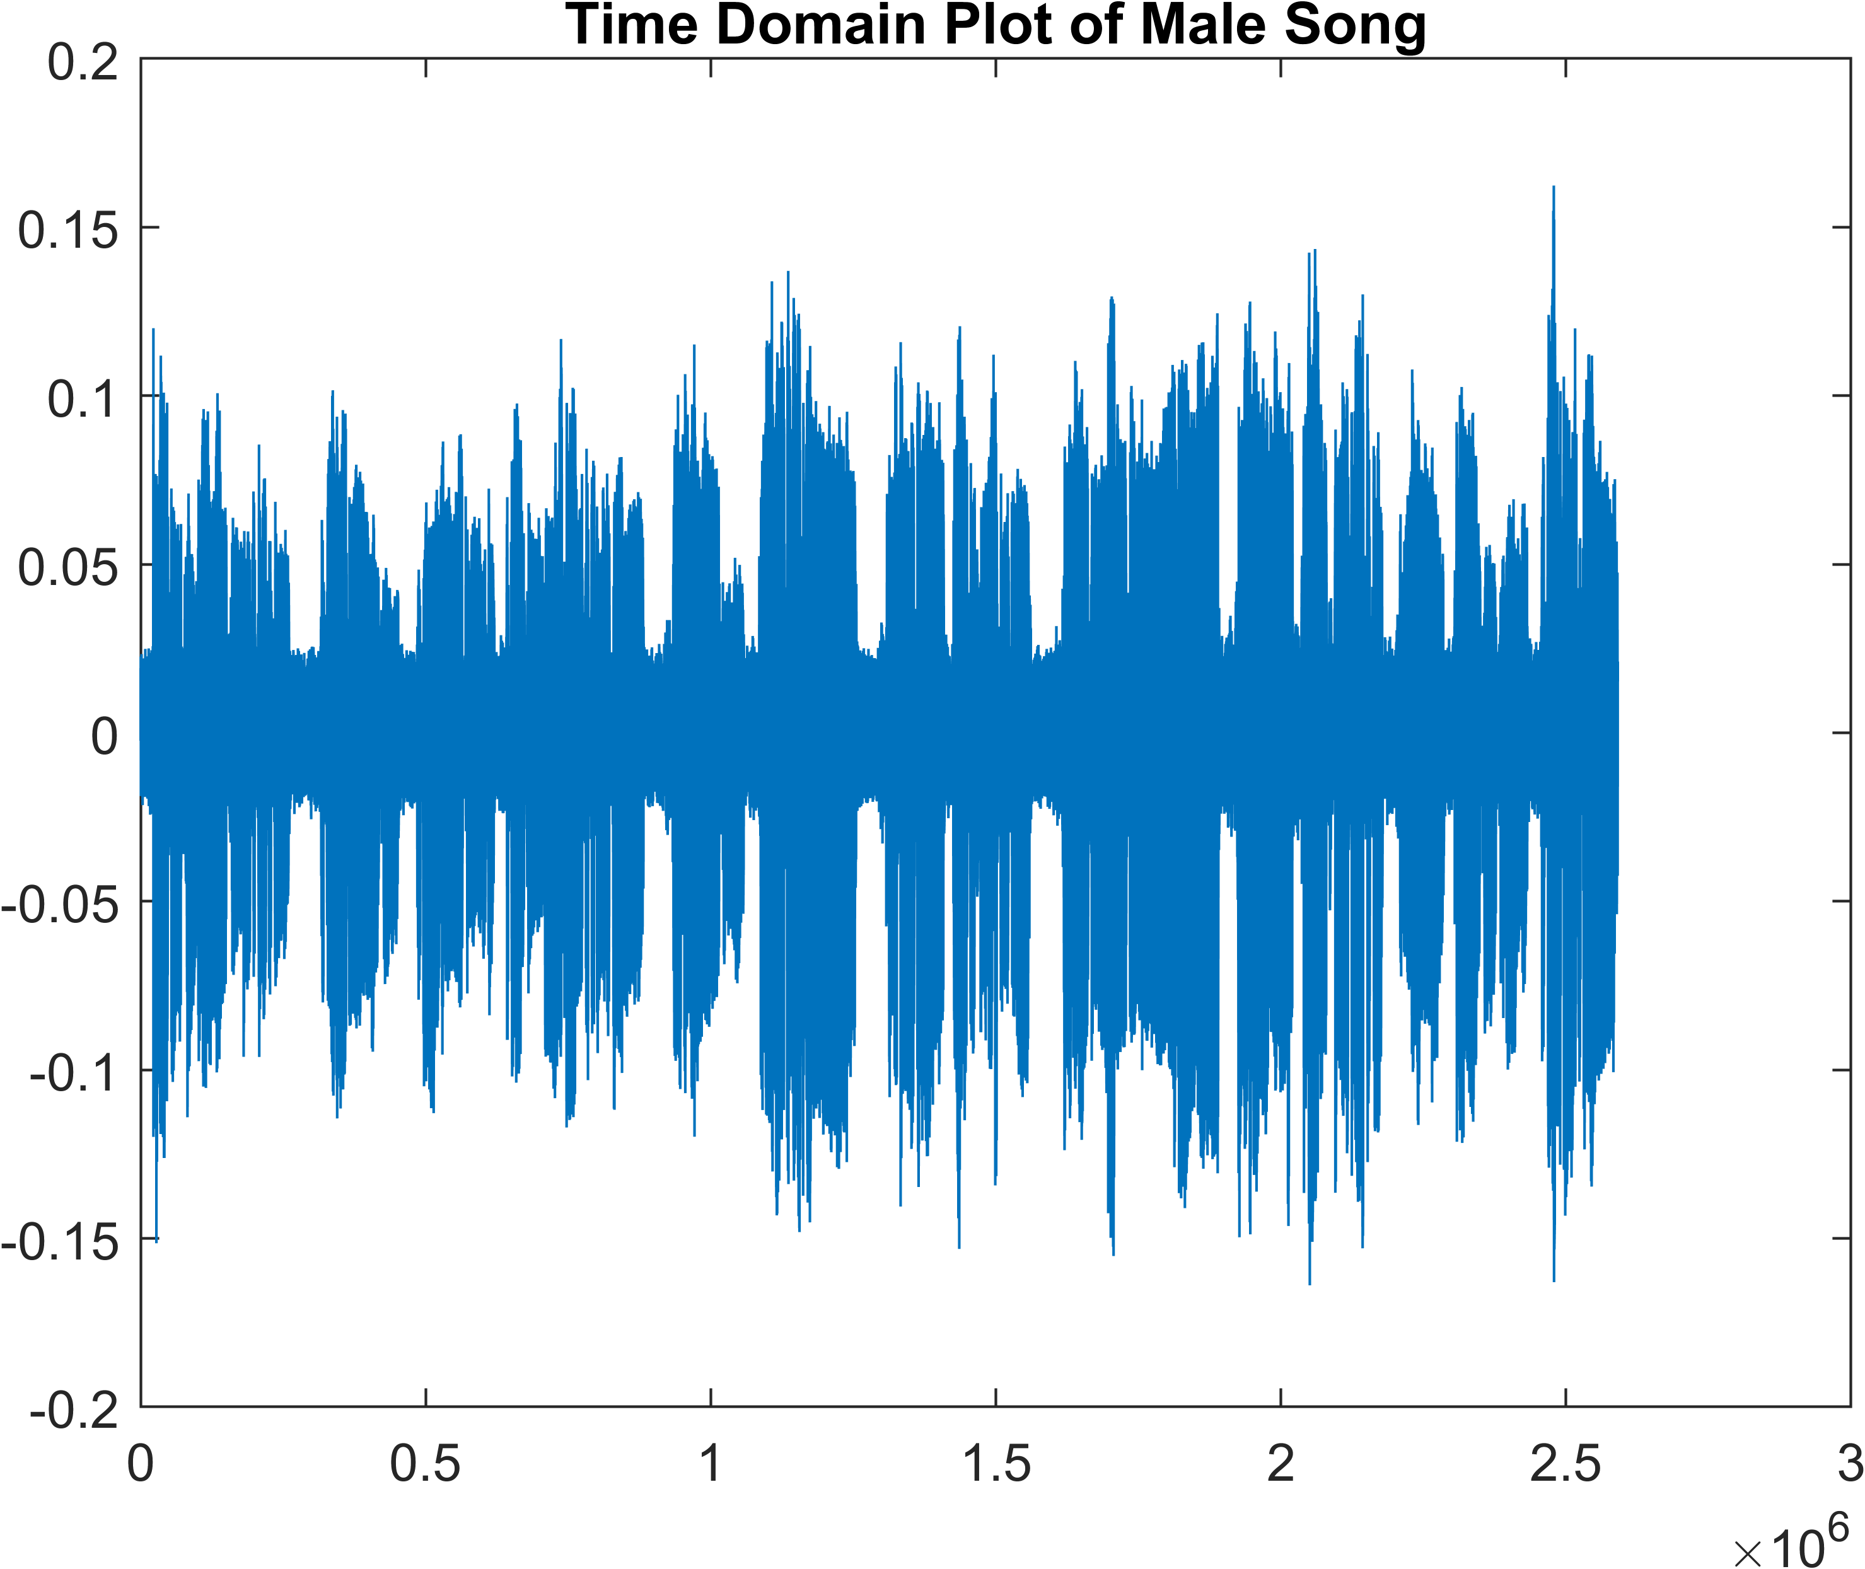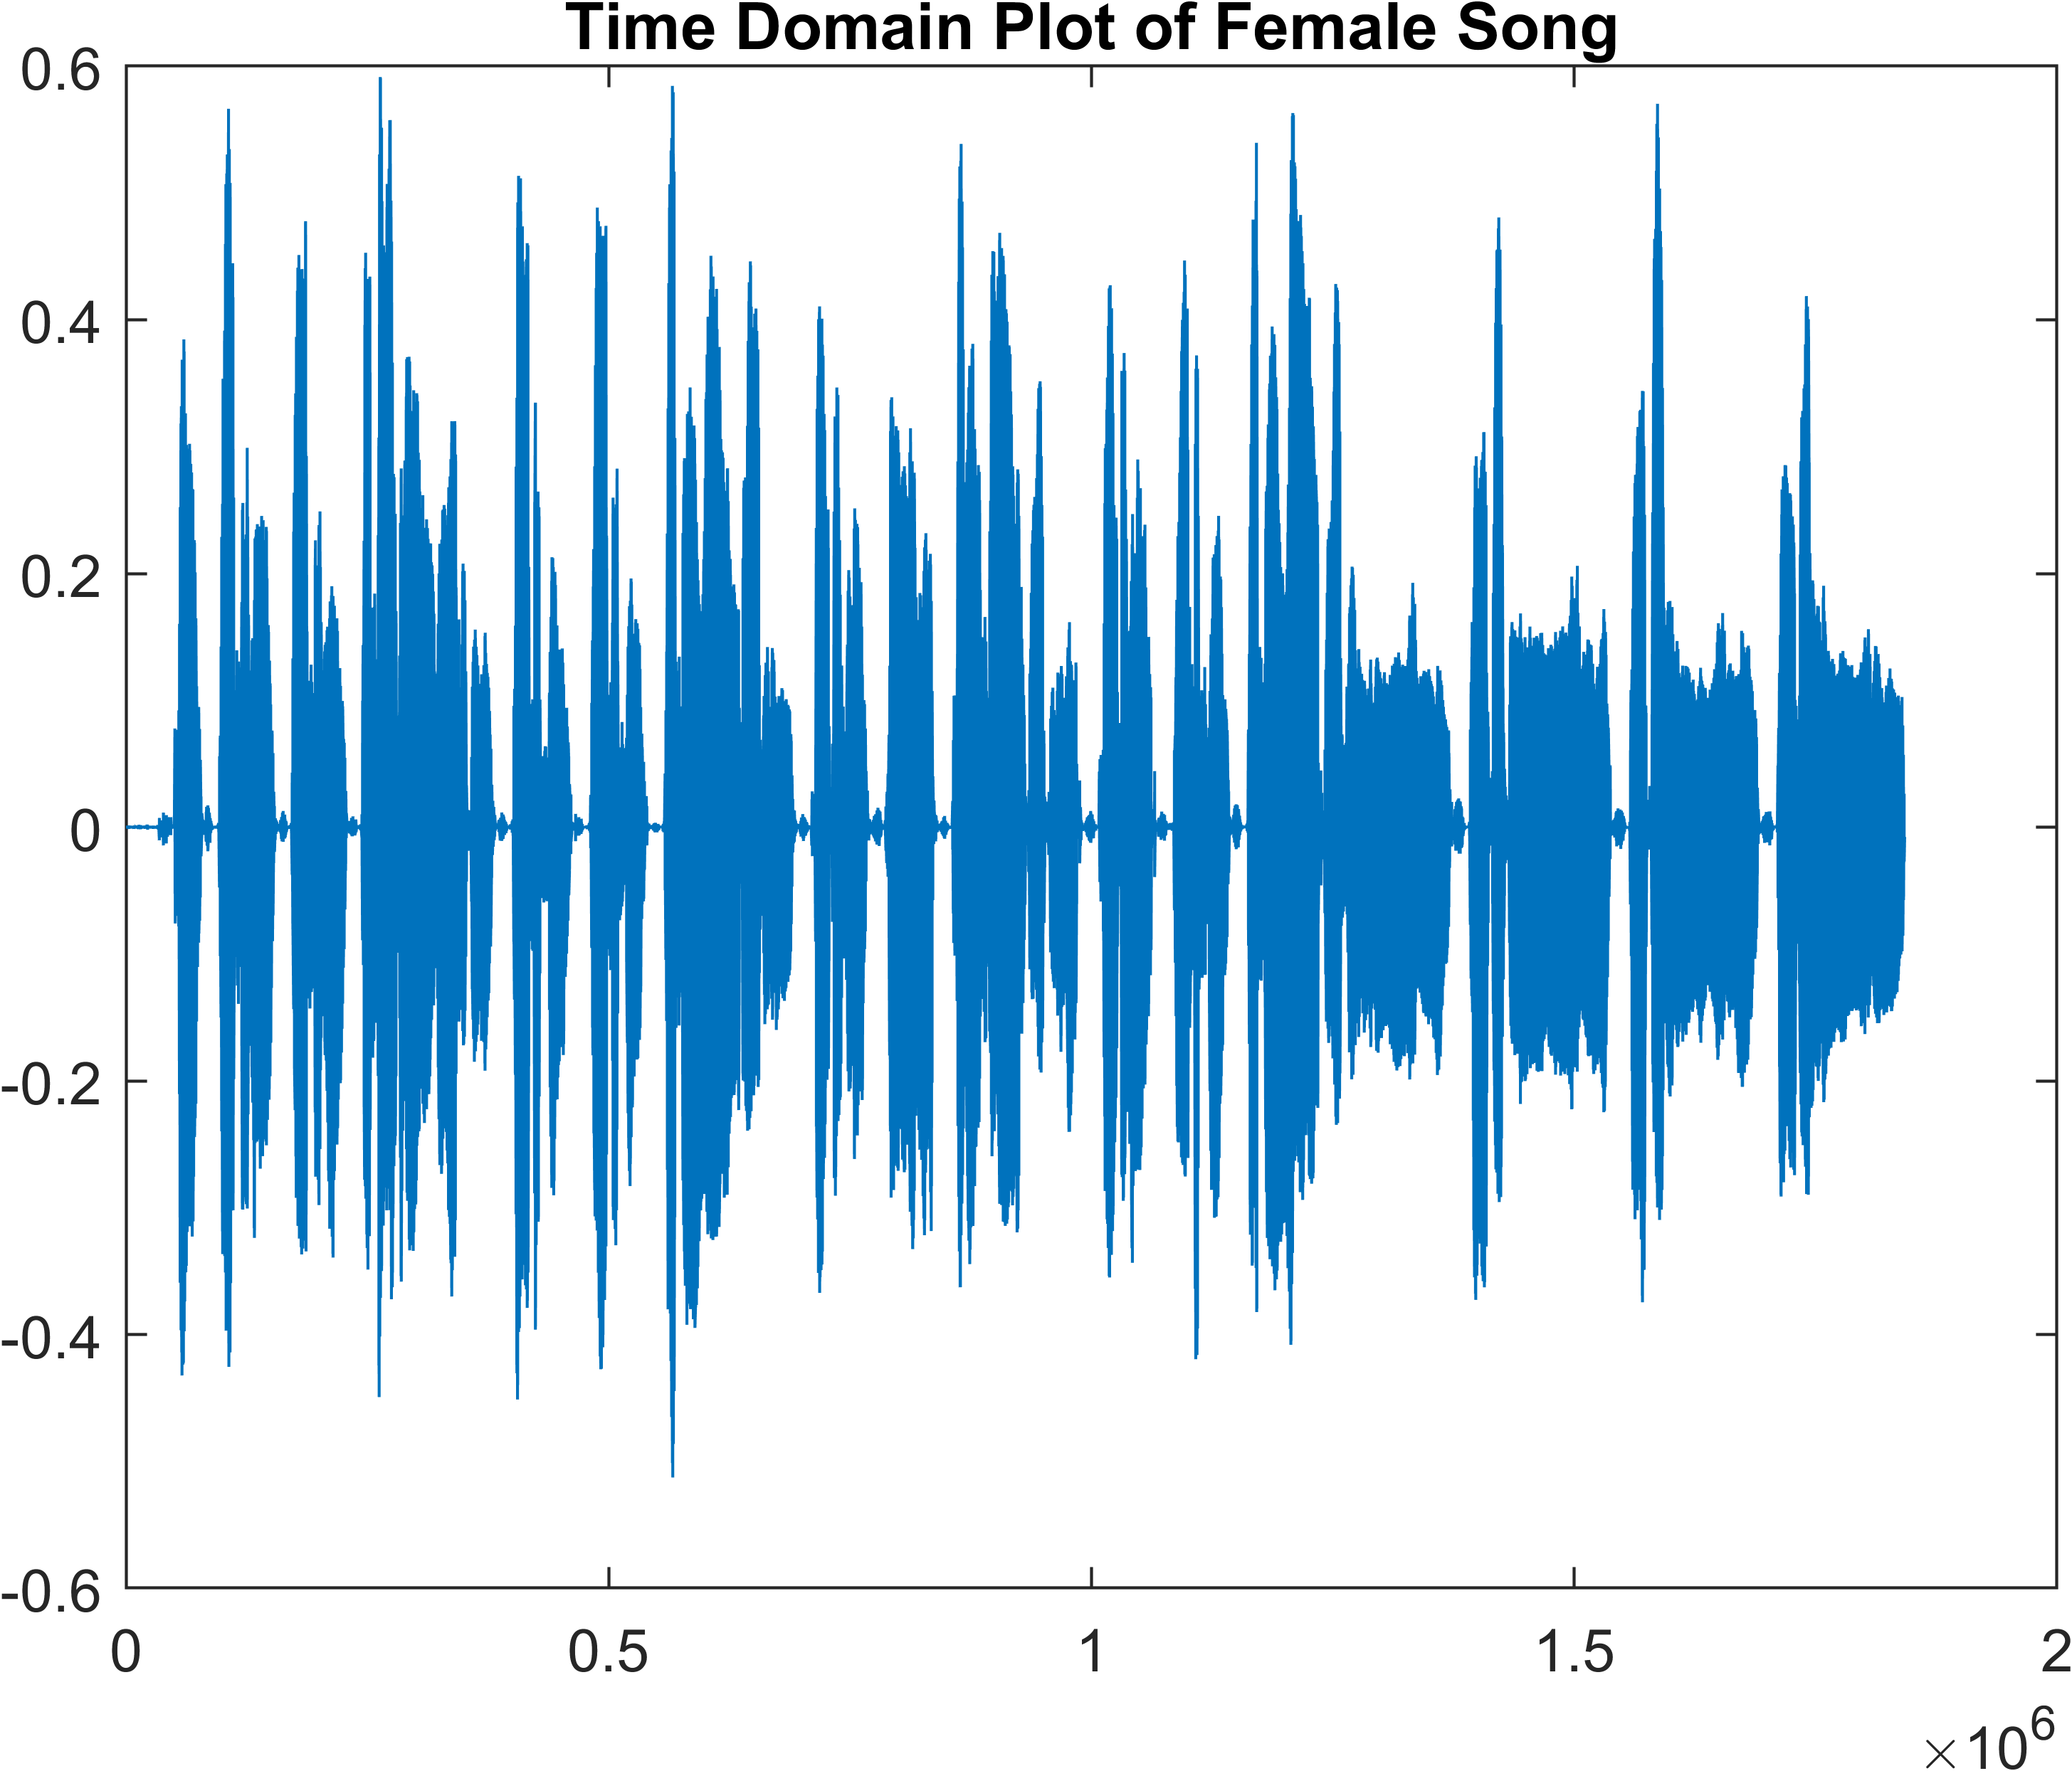

# Spectrogram

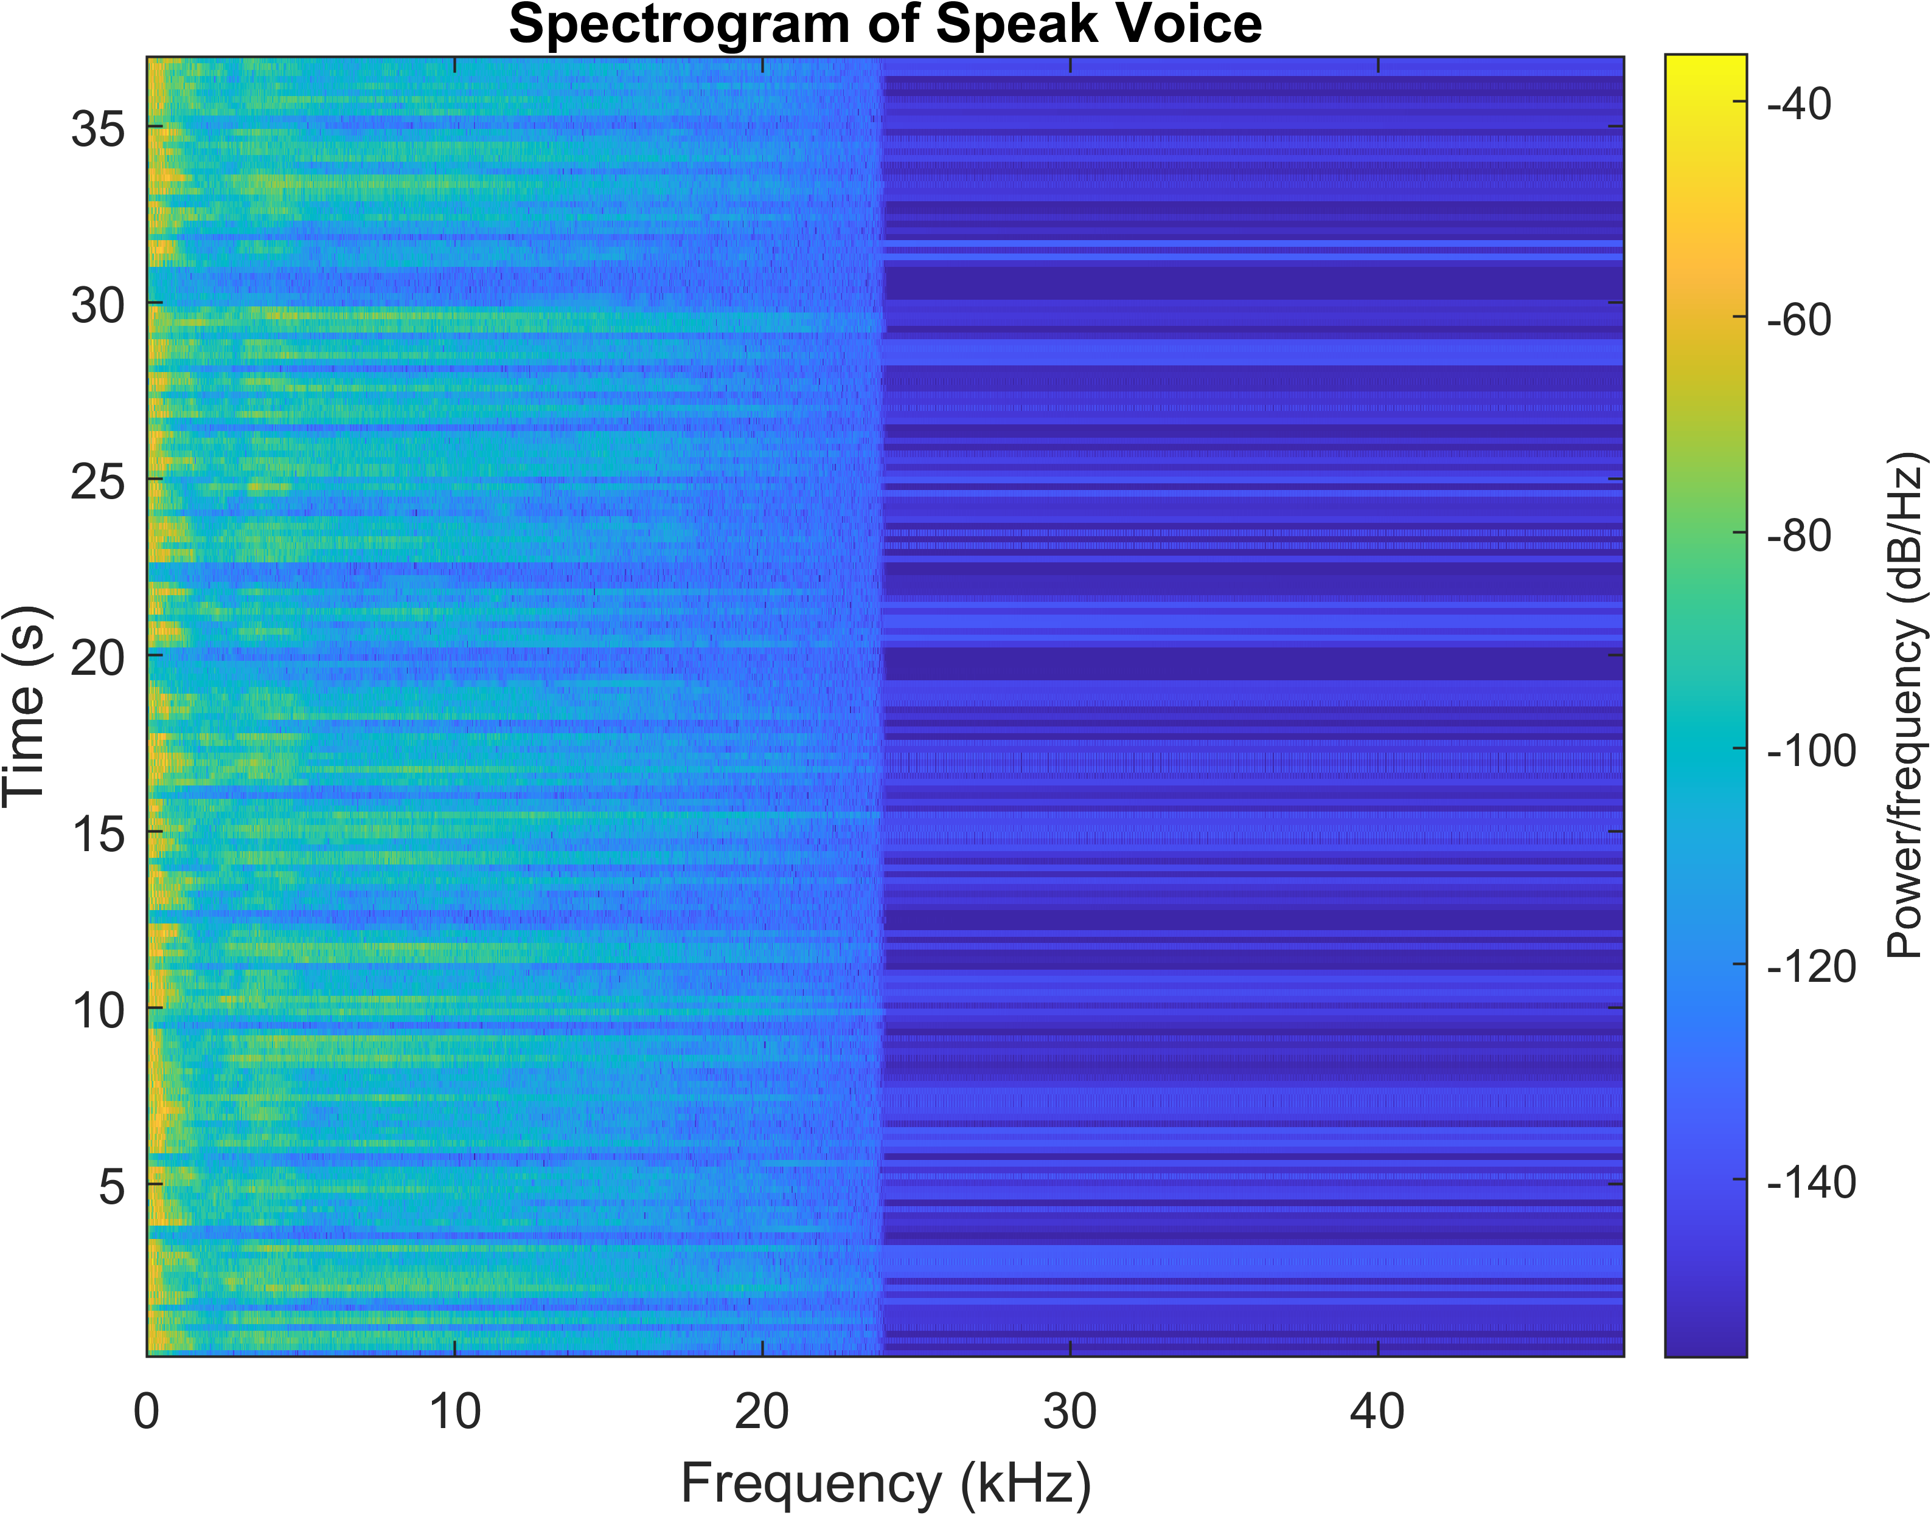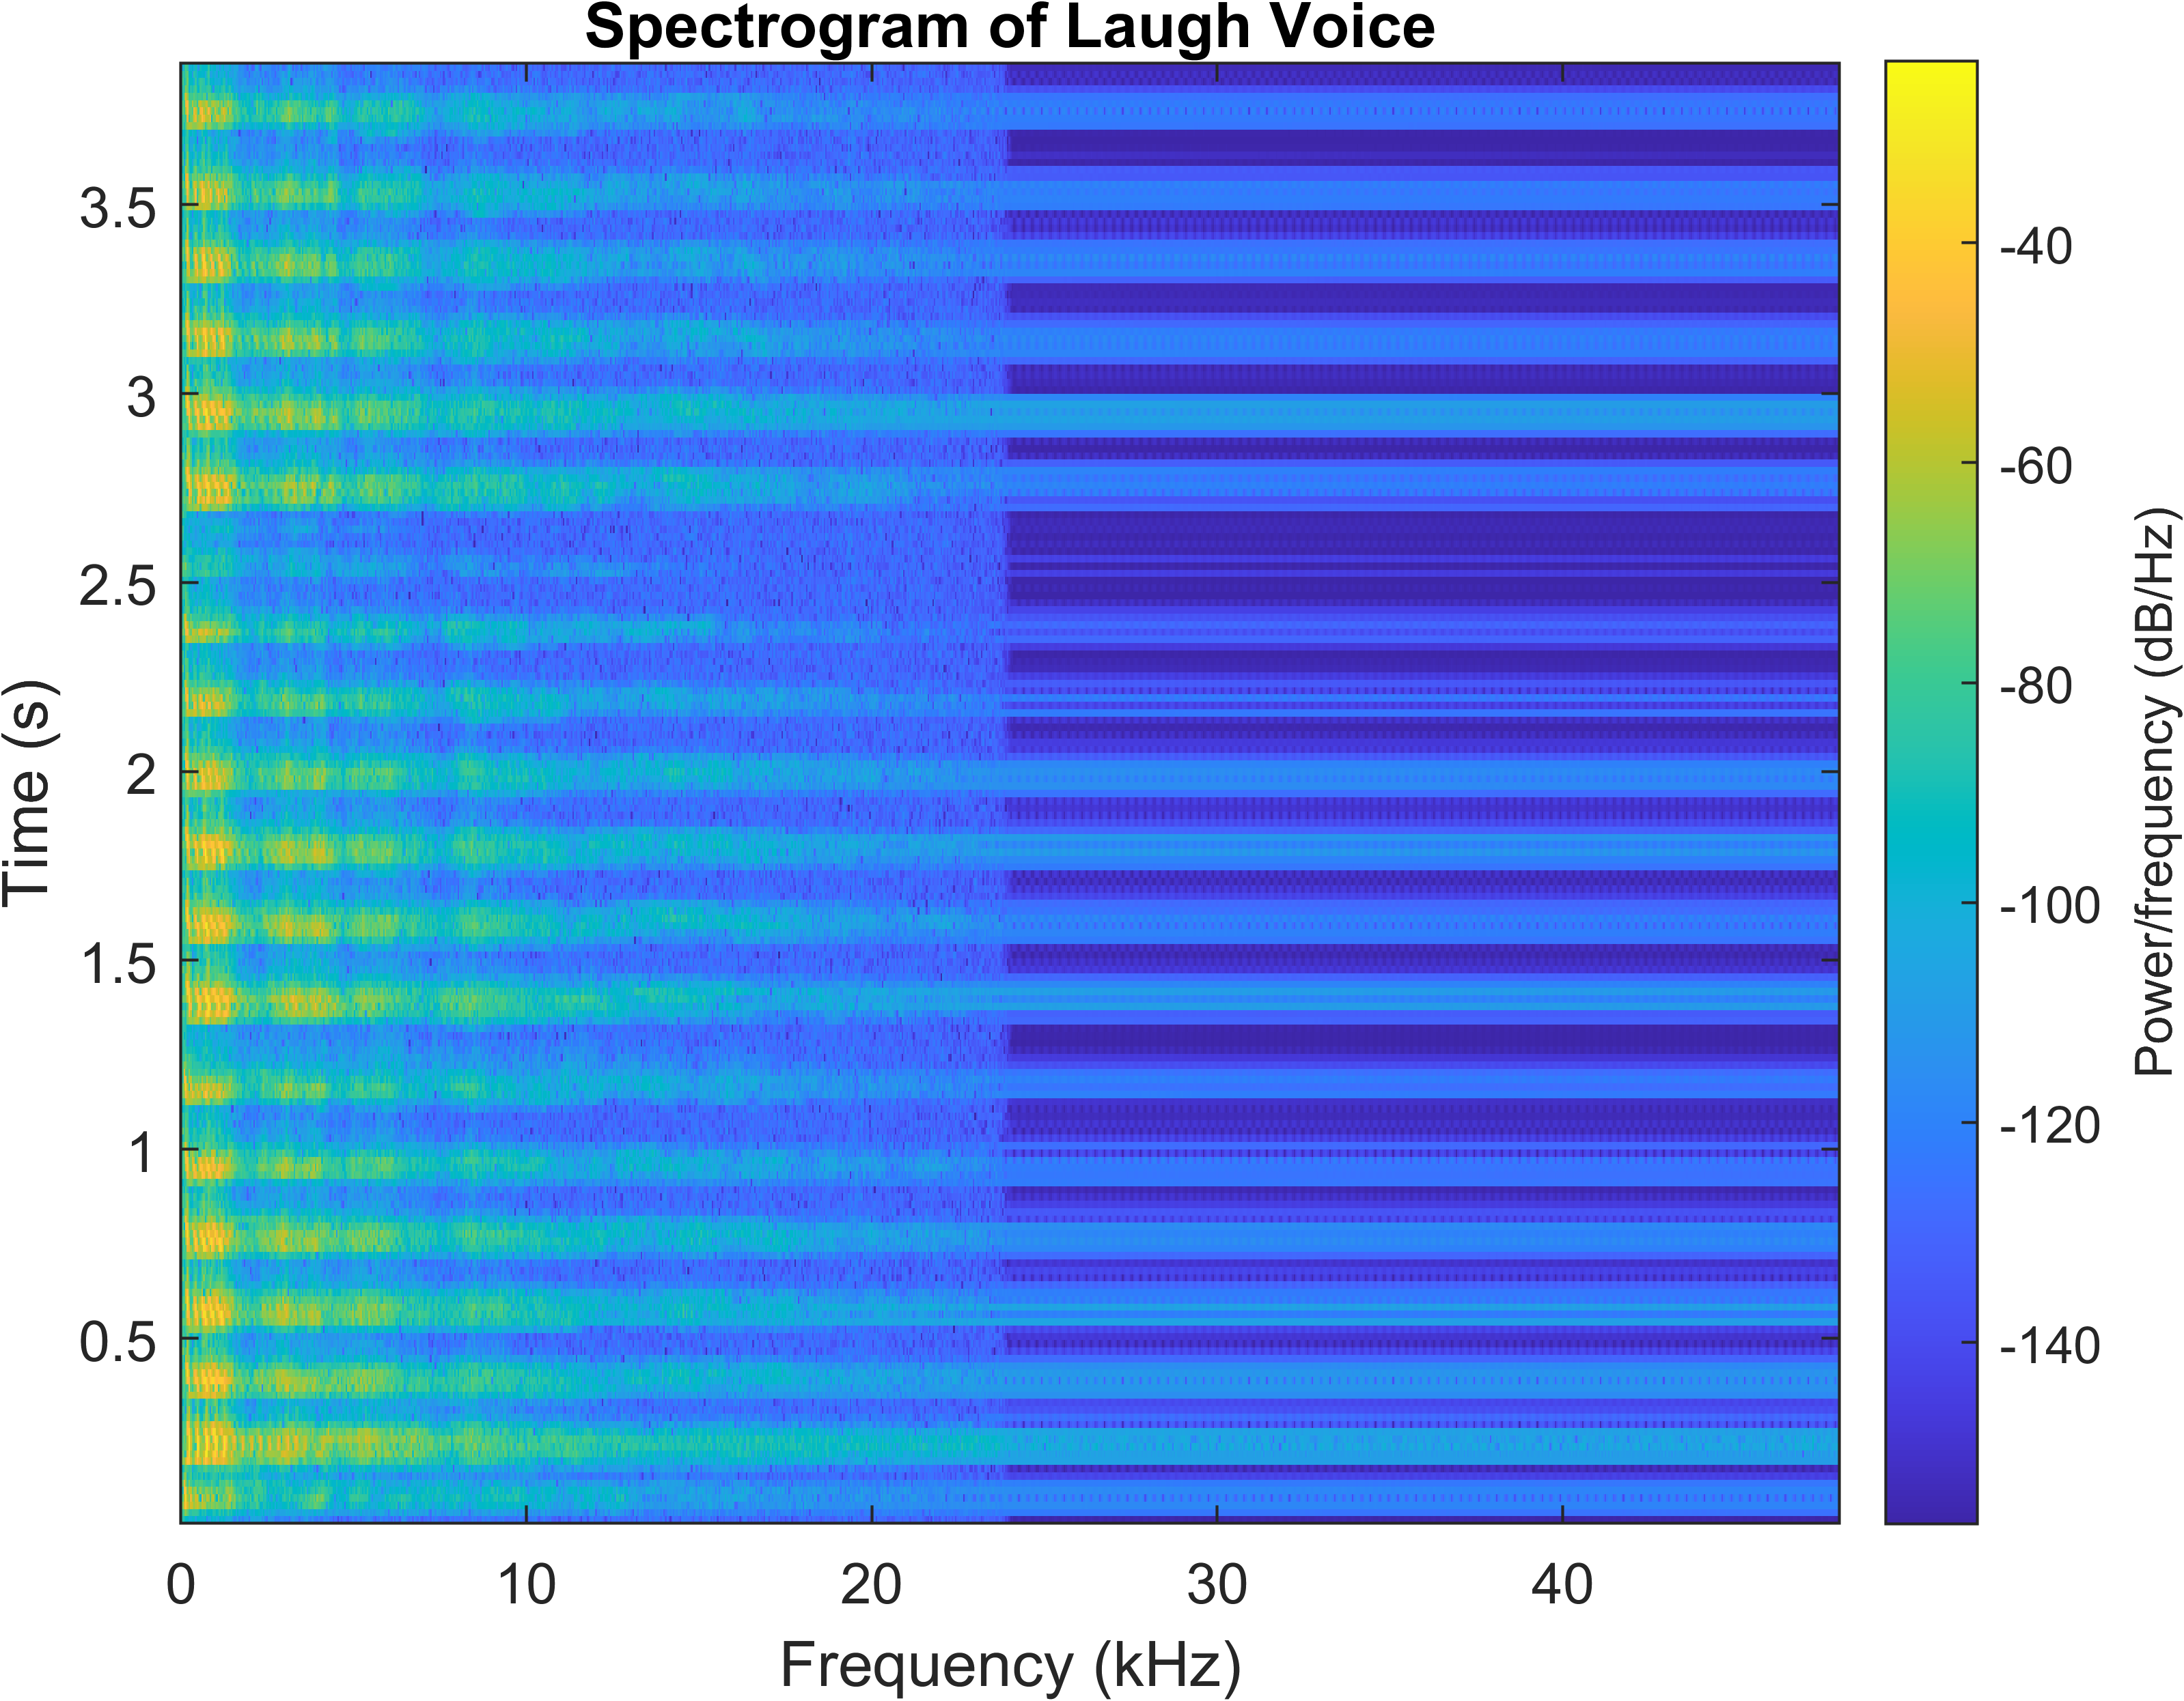

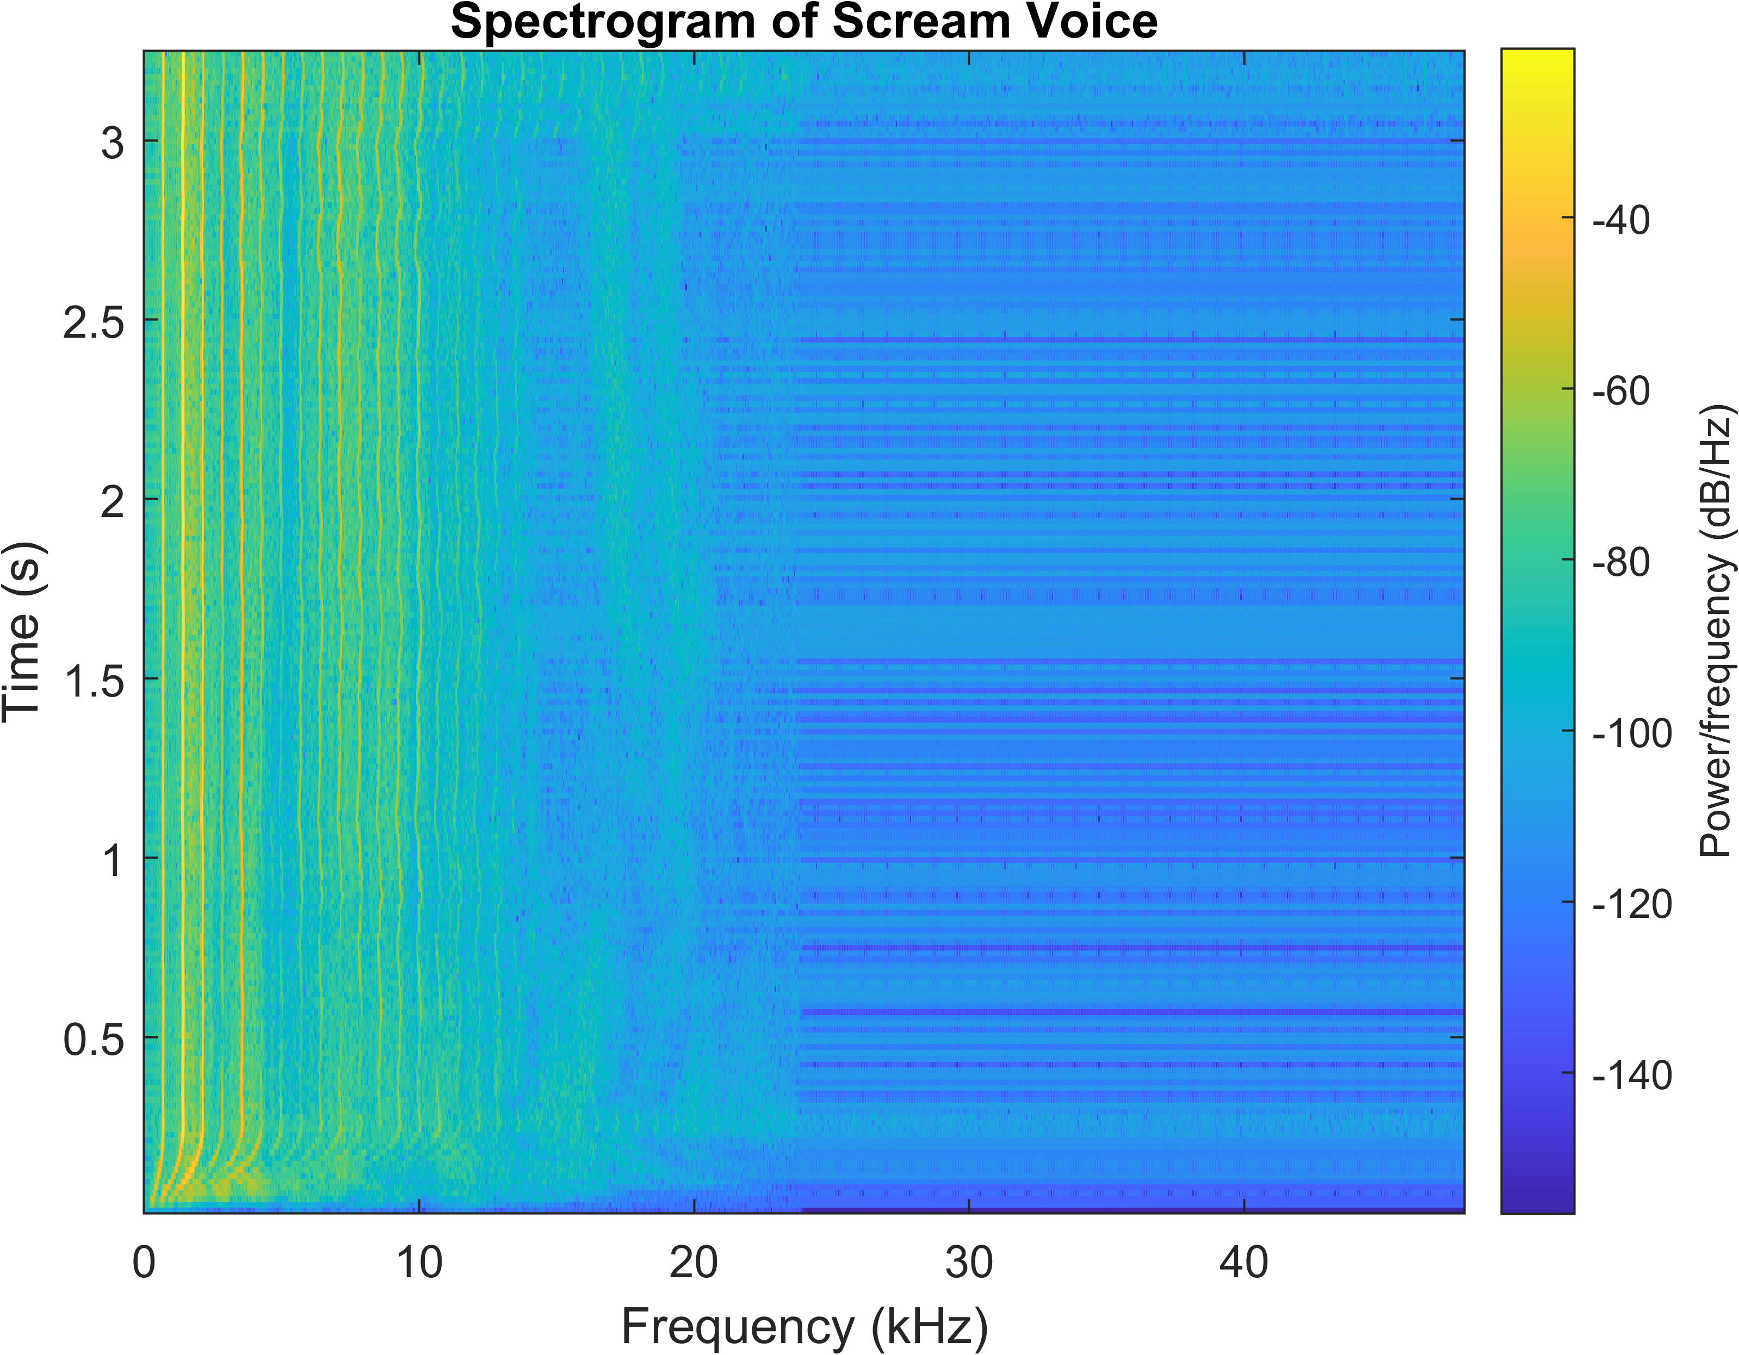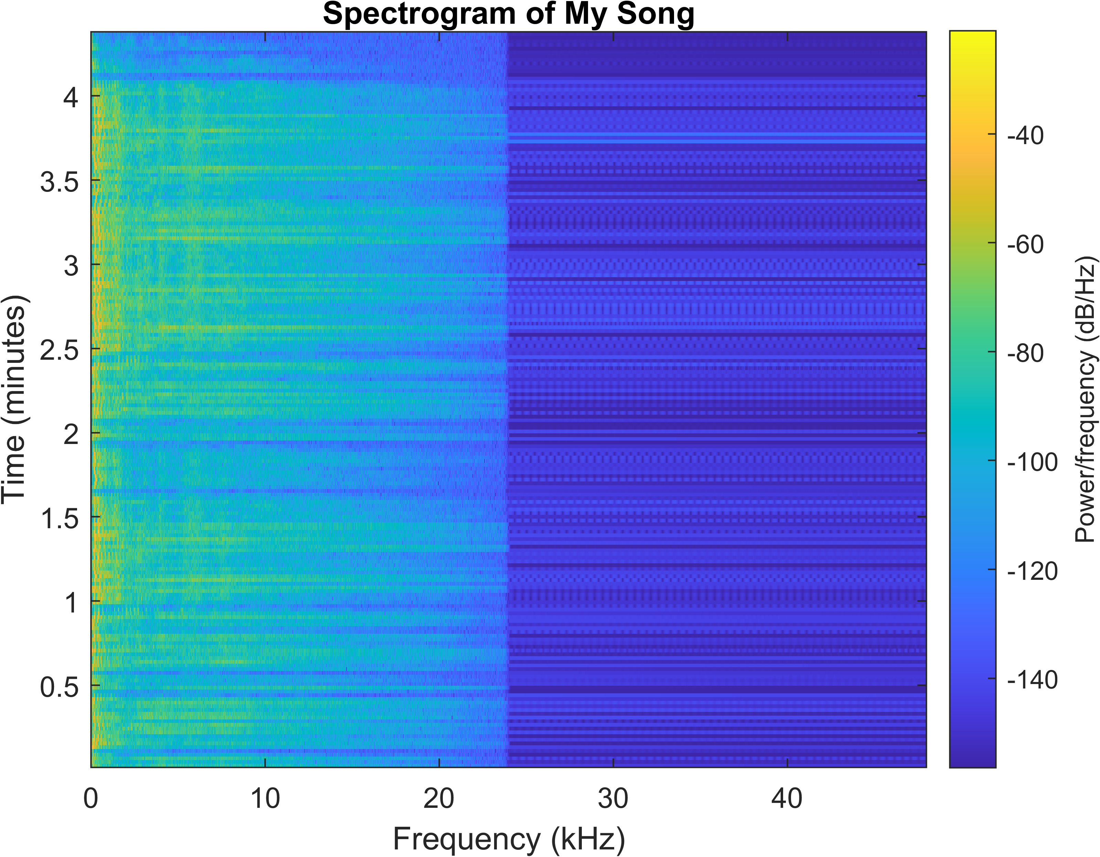

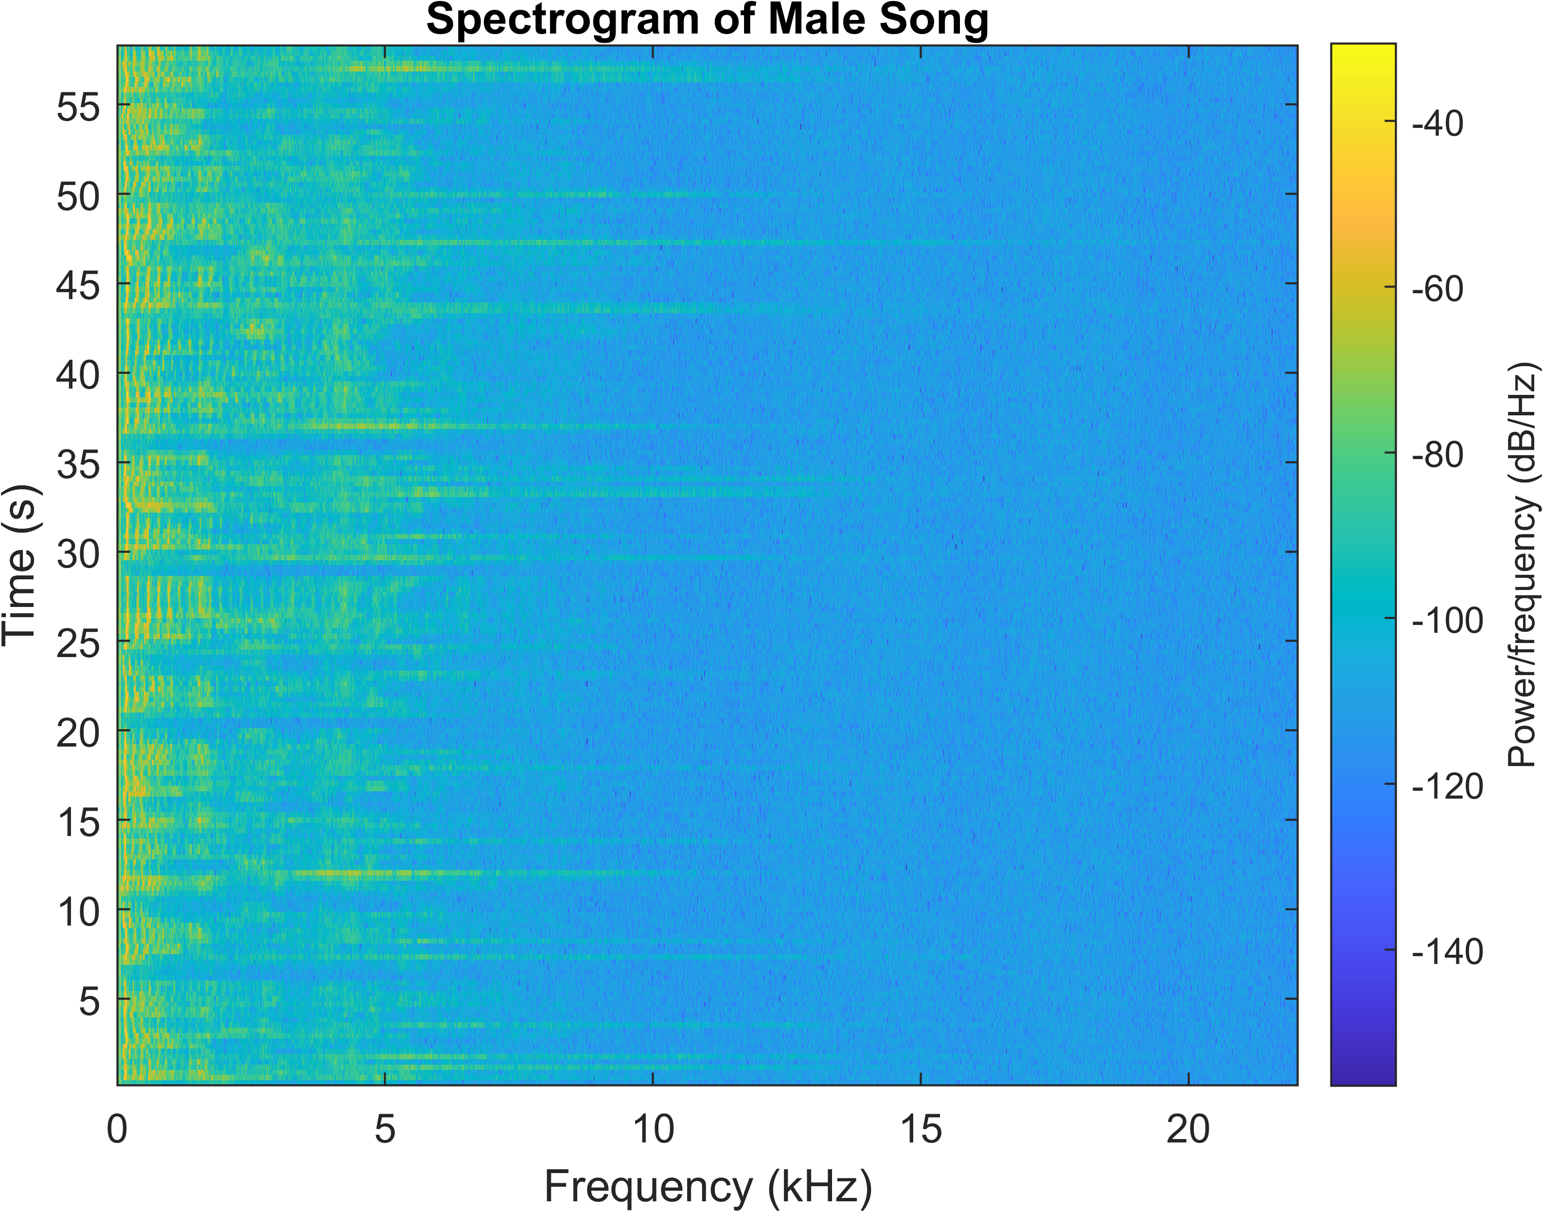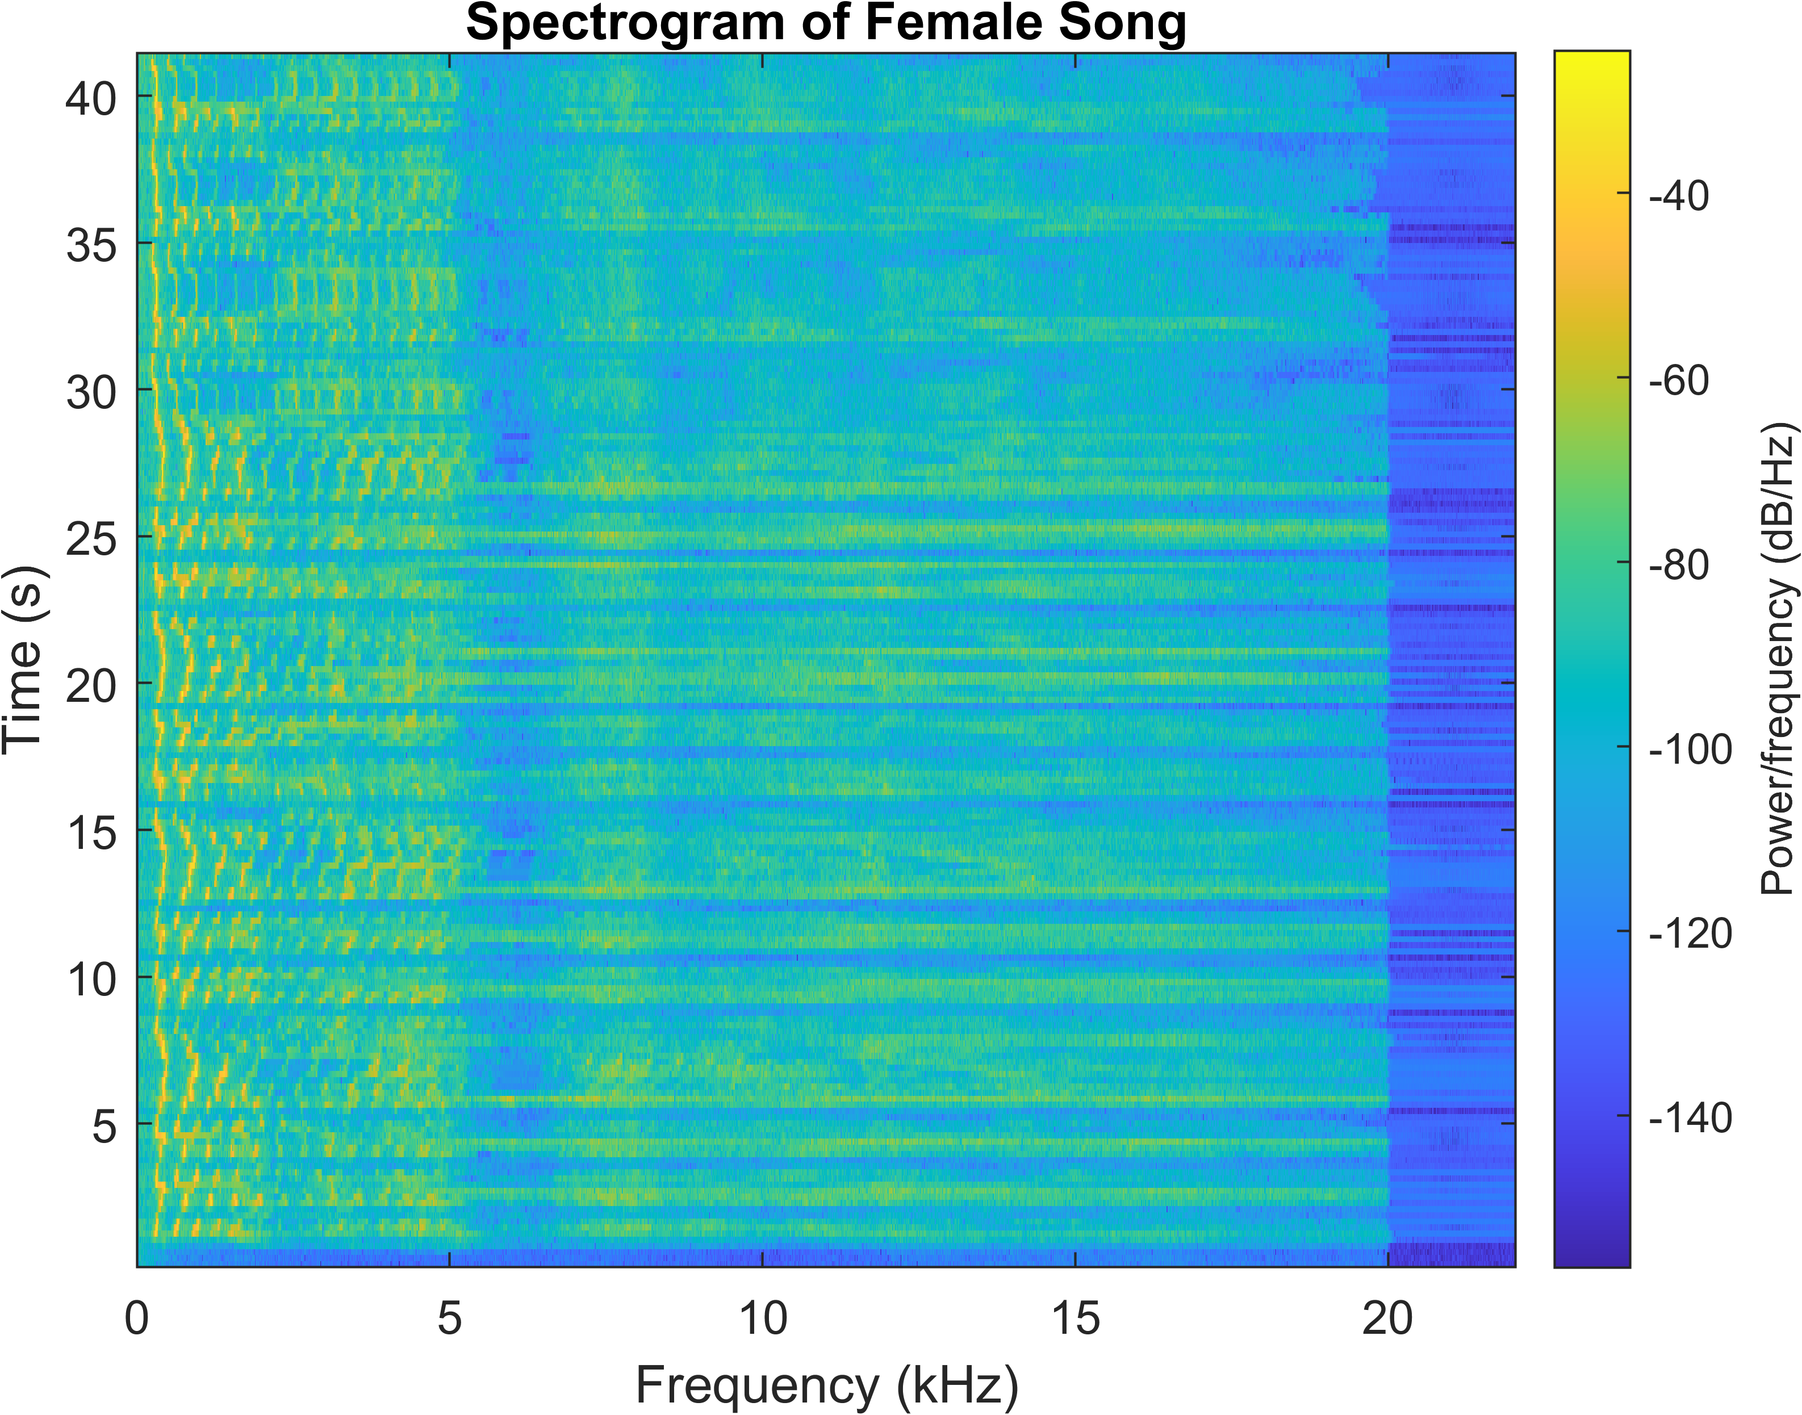

# Frequency Analysis

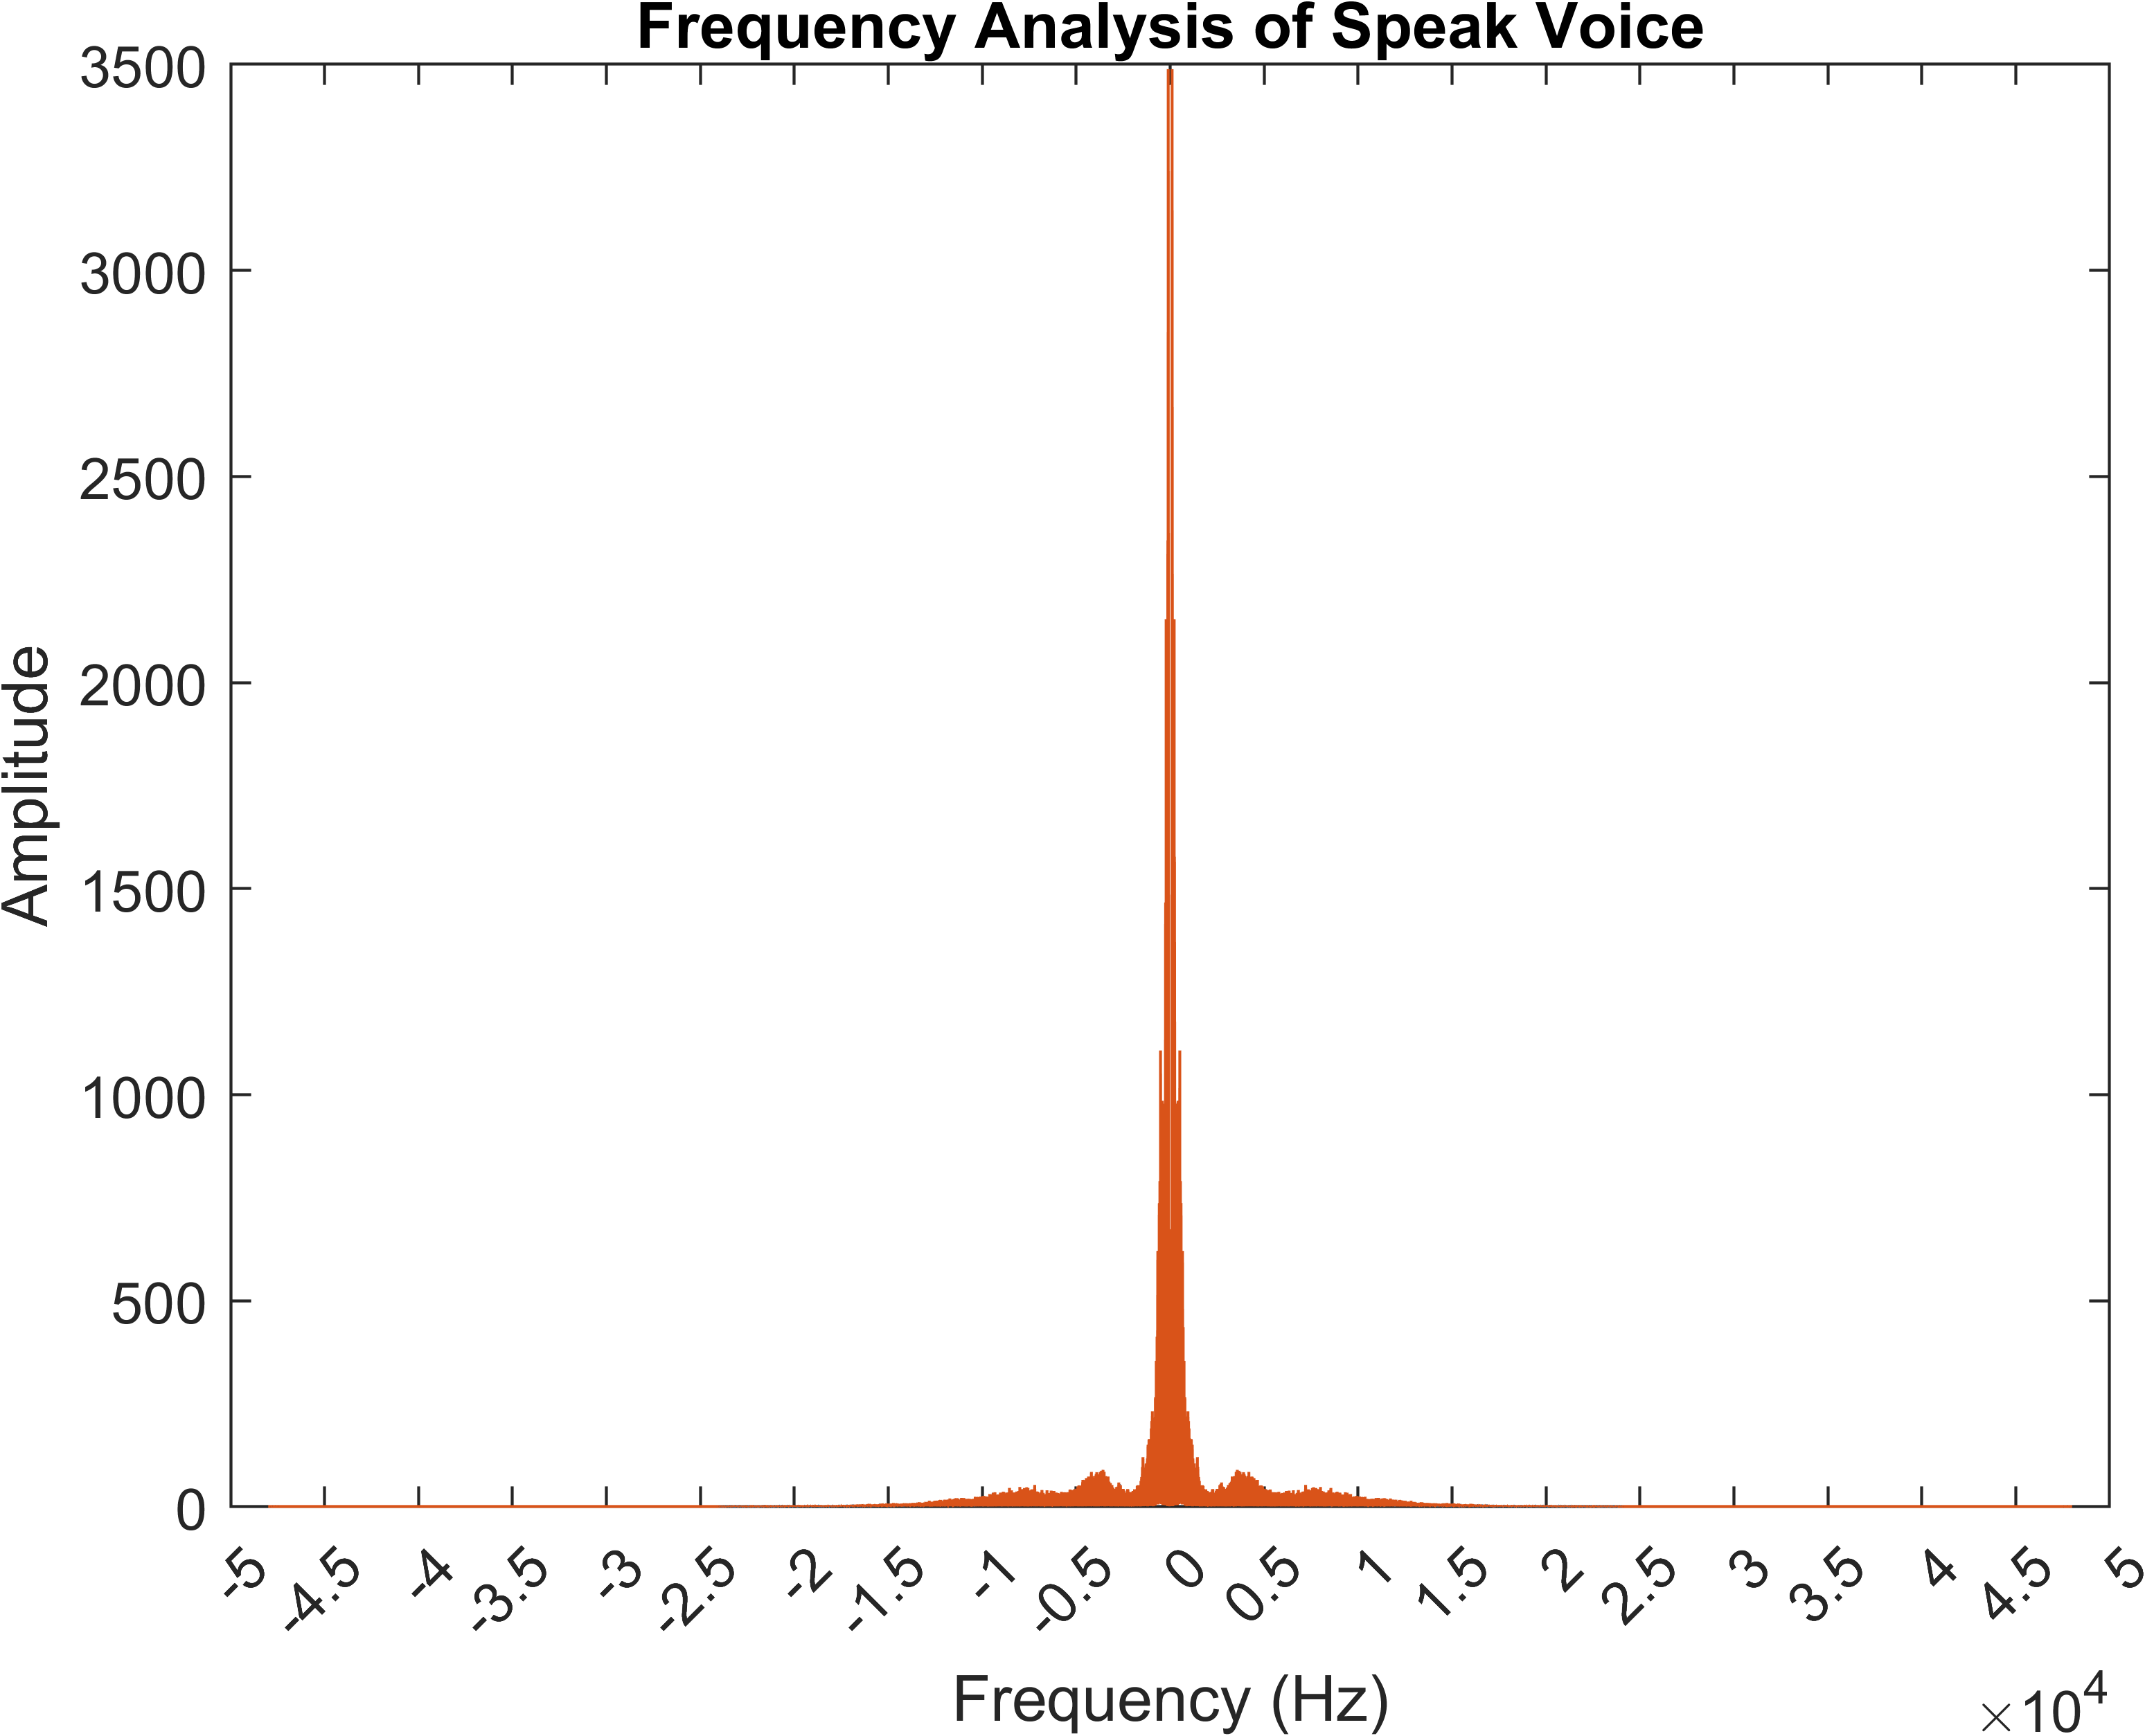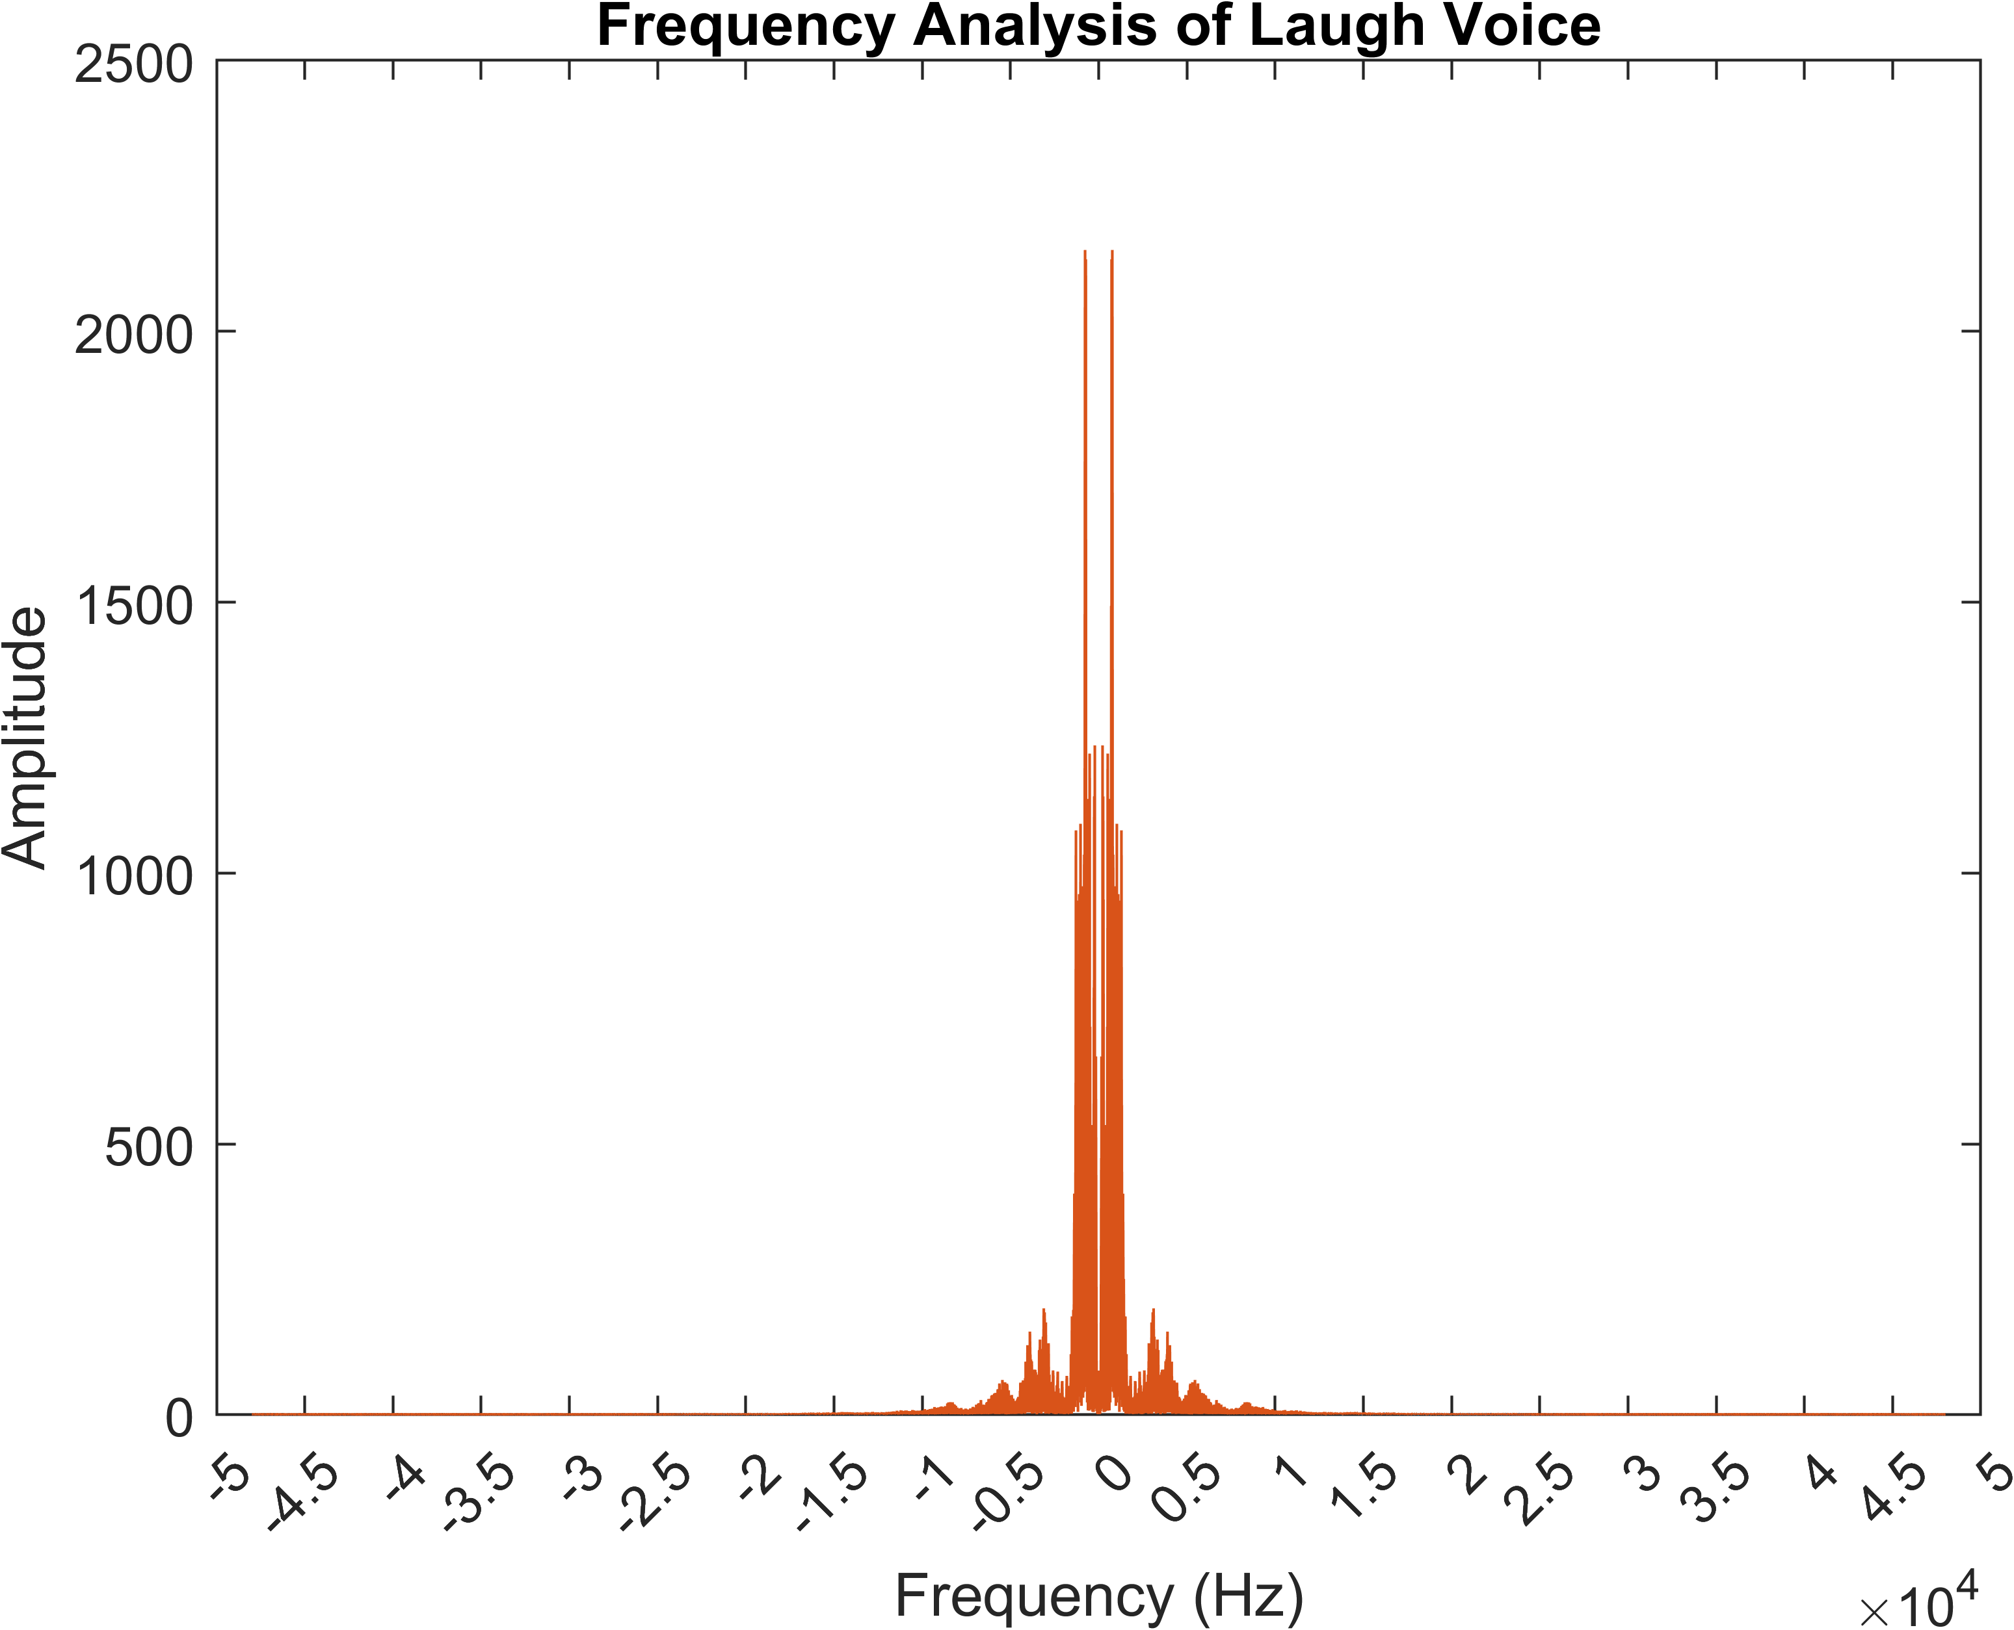

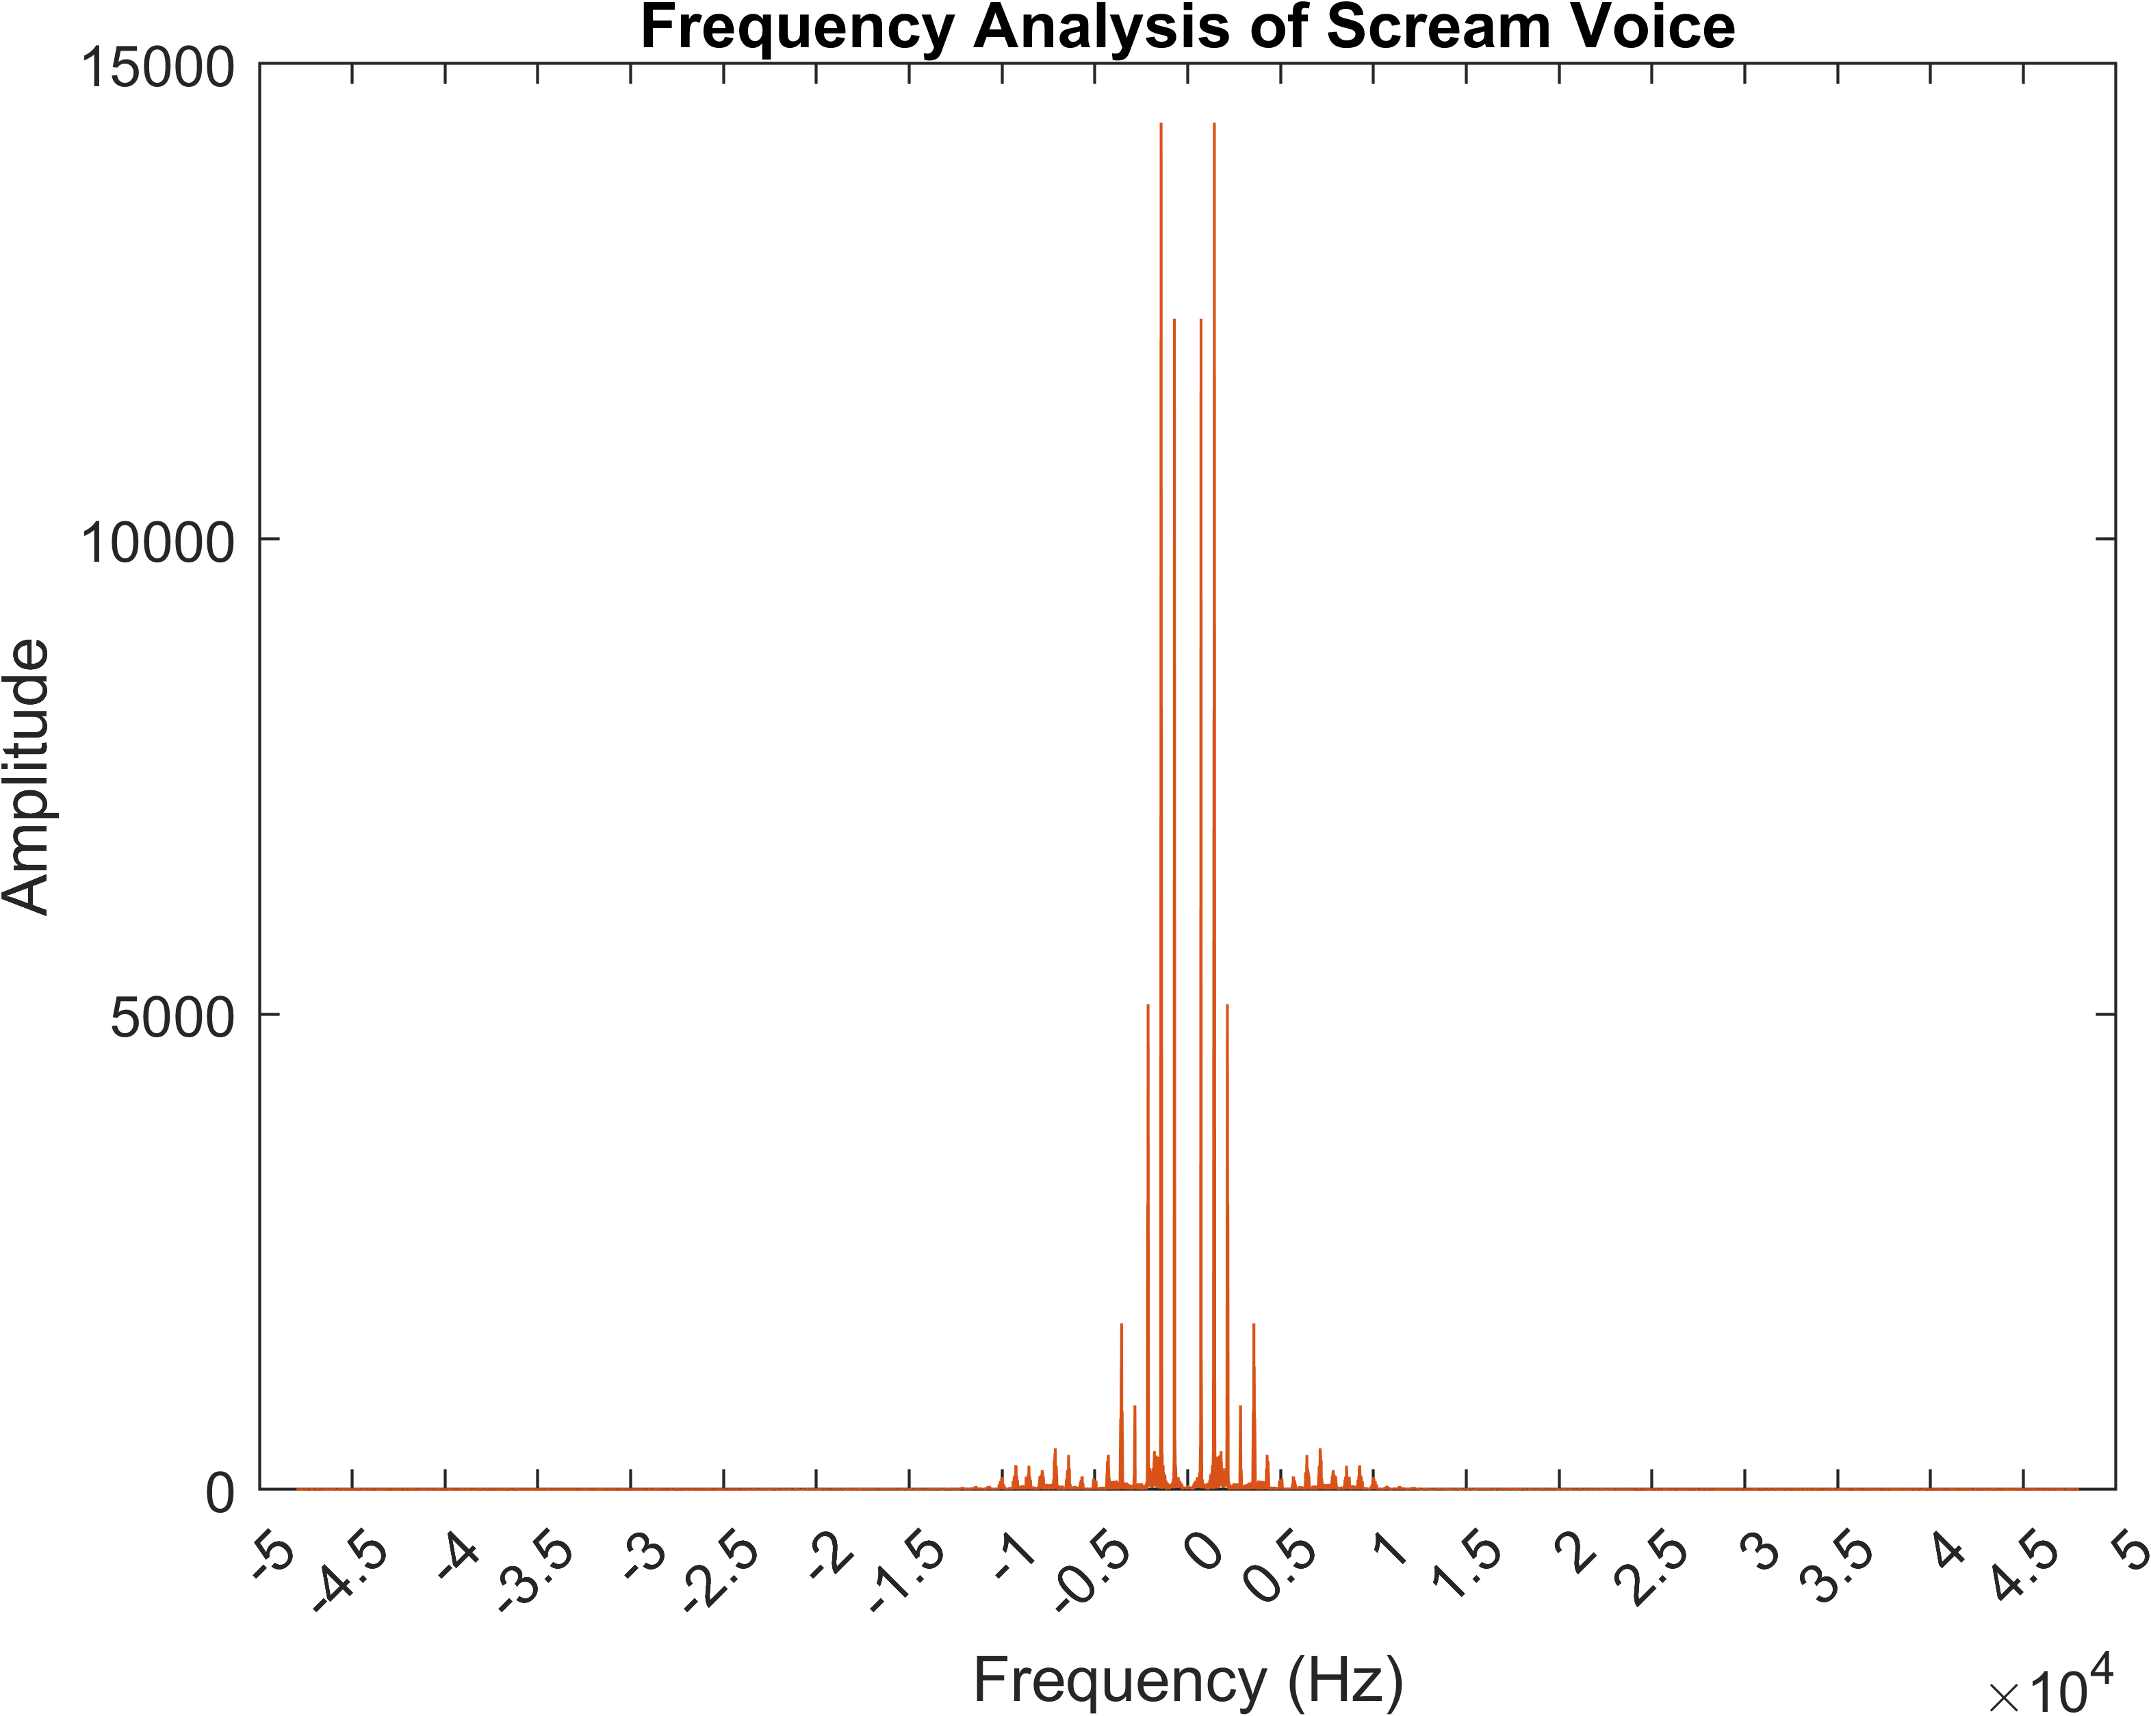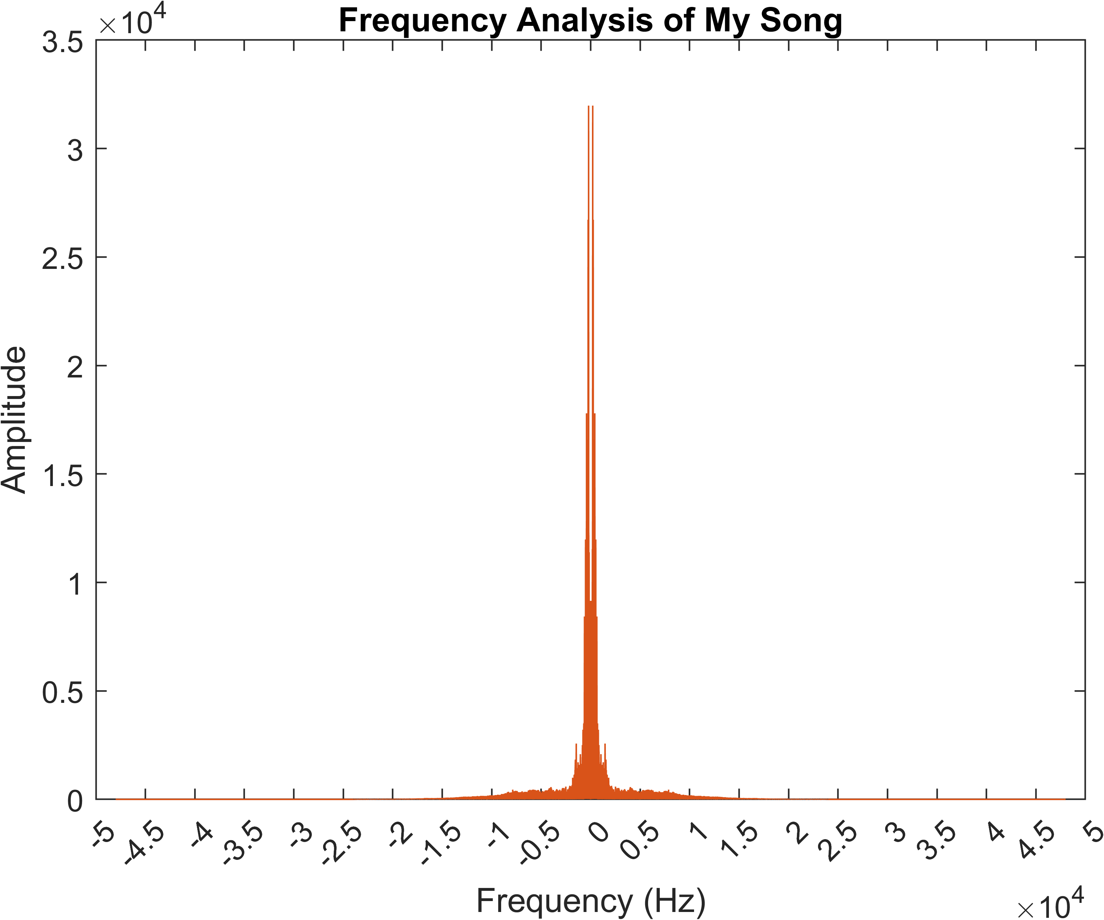

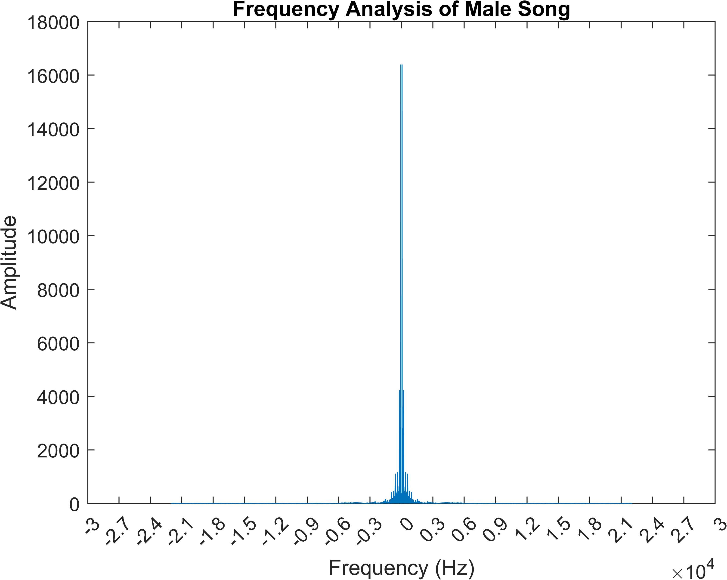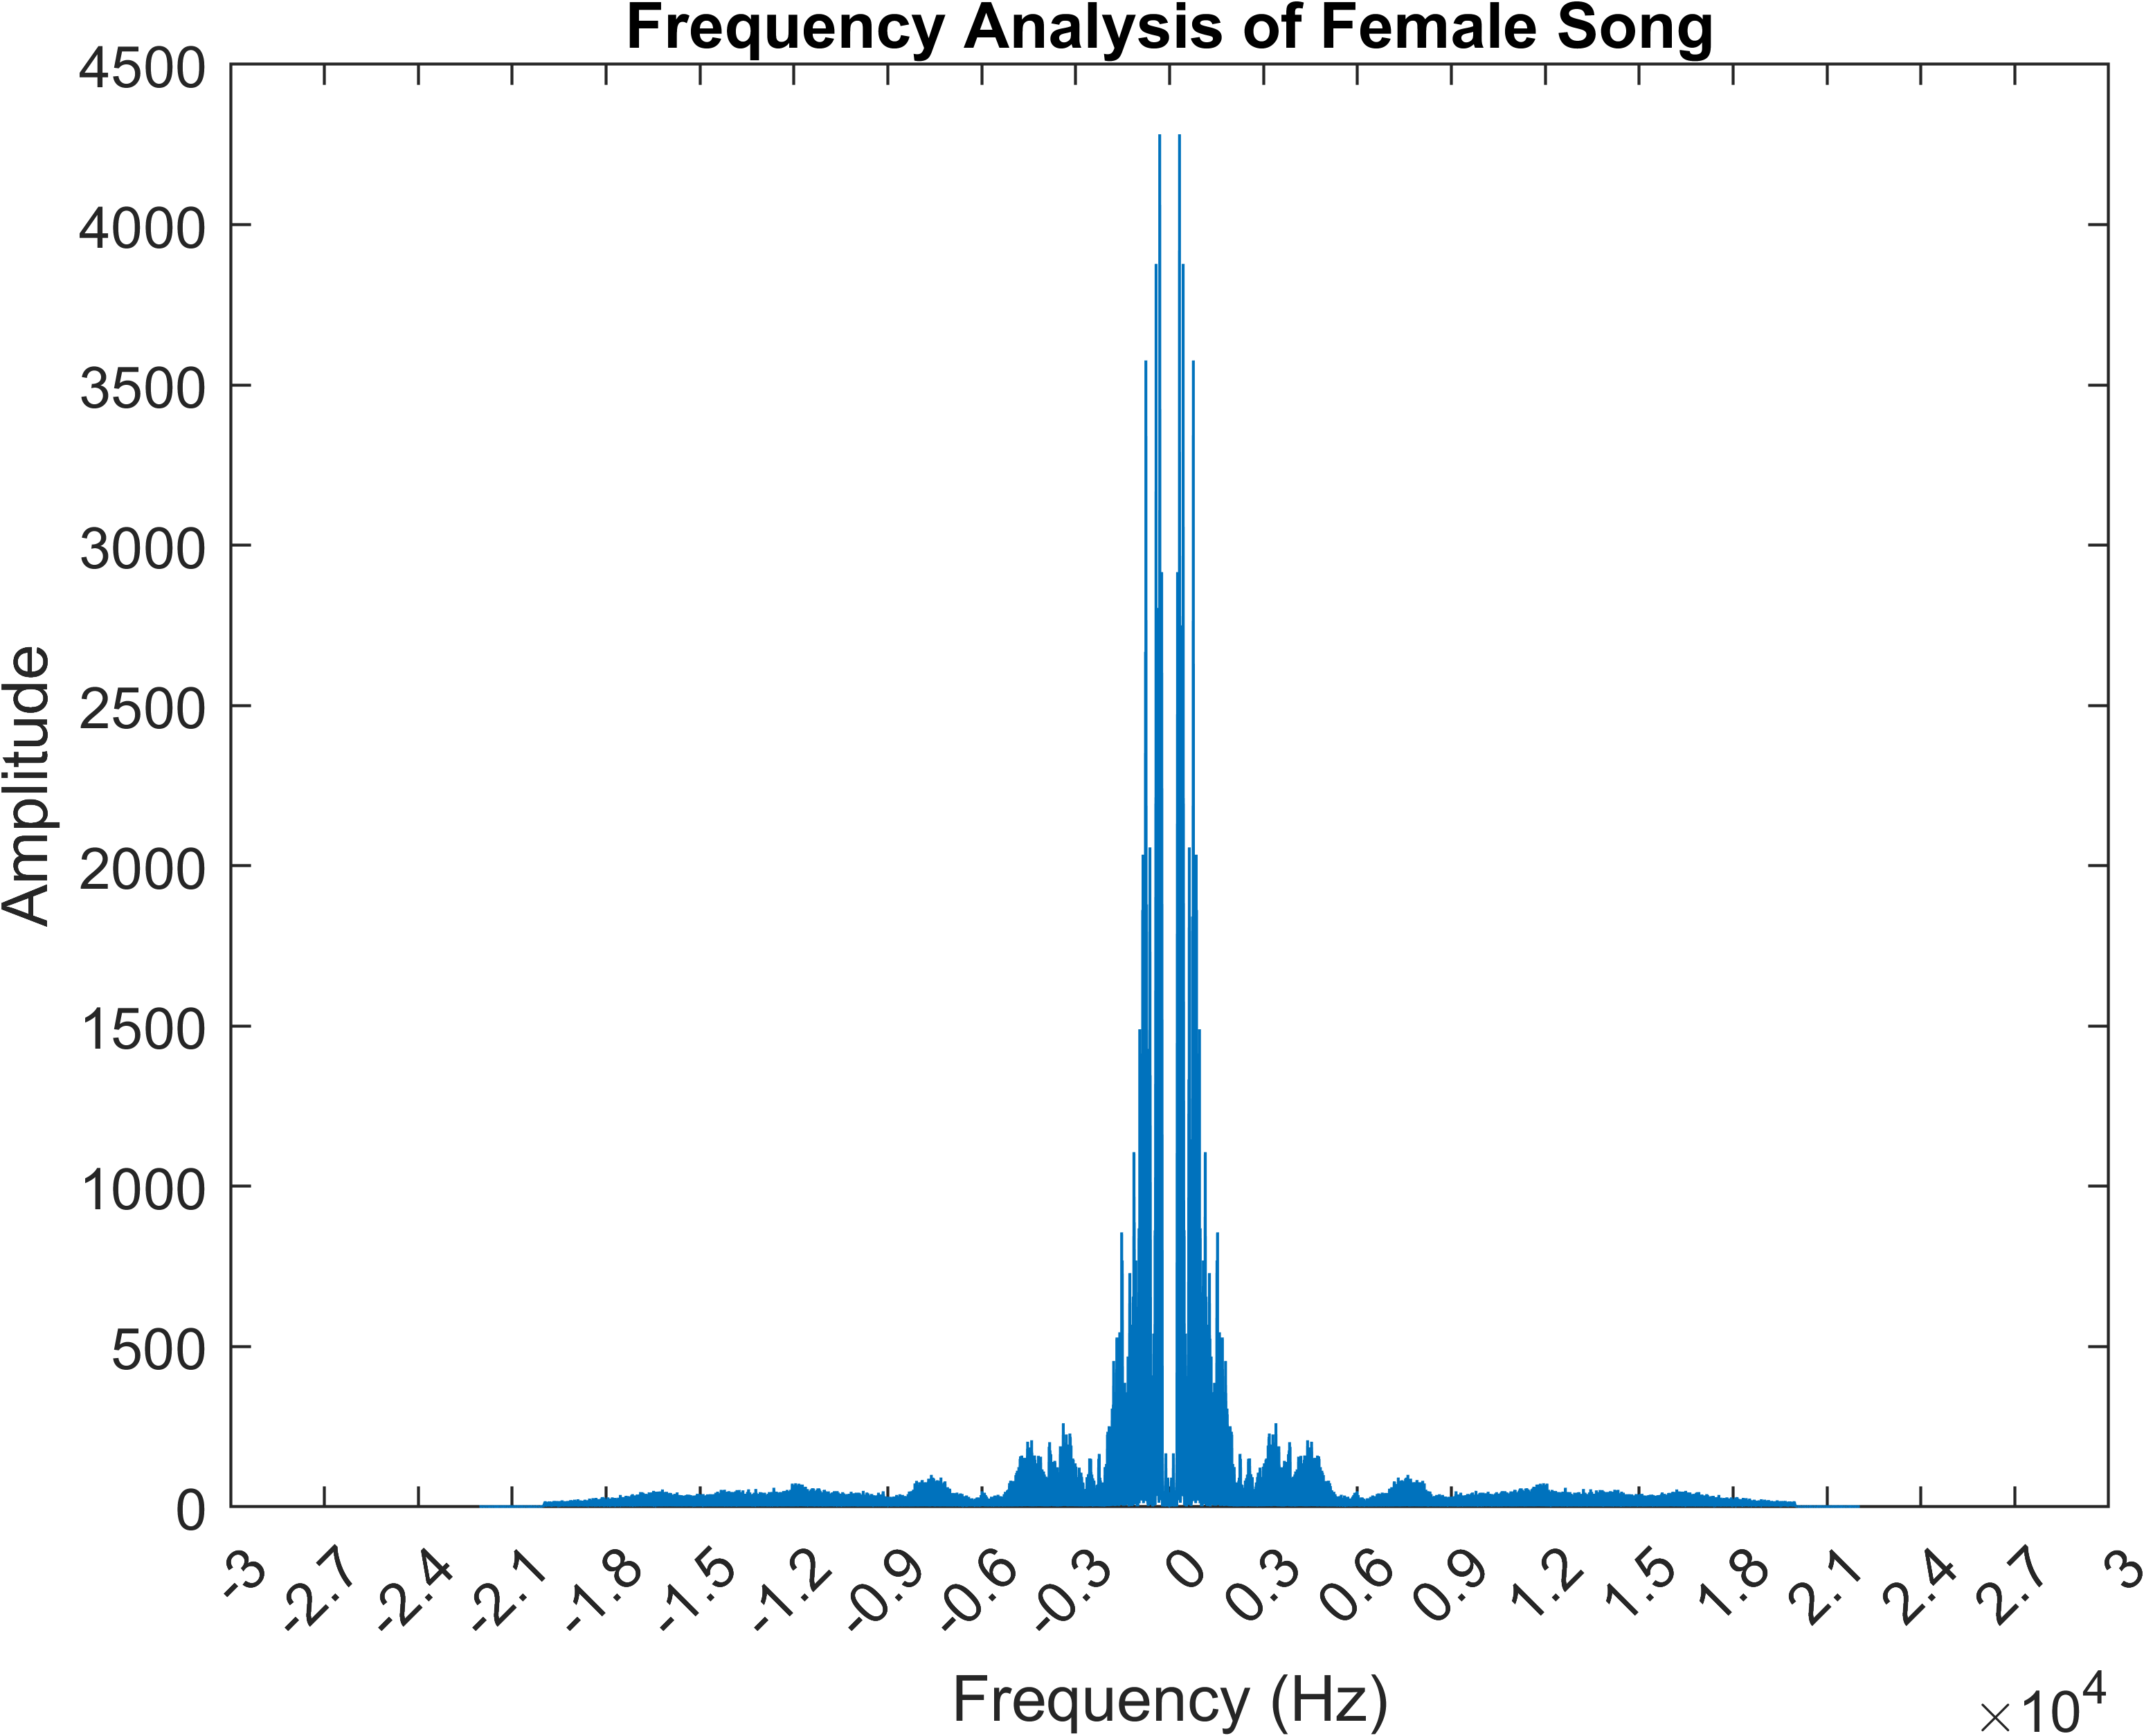

# Frequency Analysis (taking logarithm)

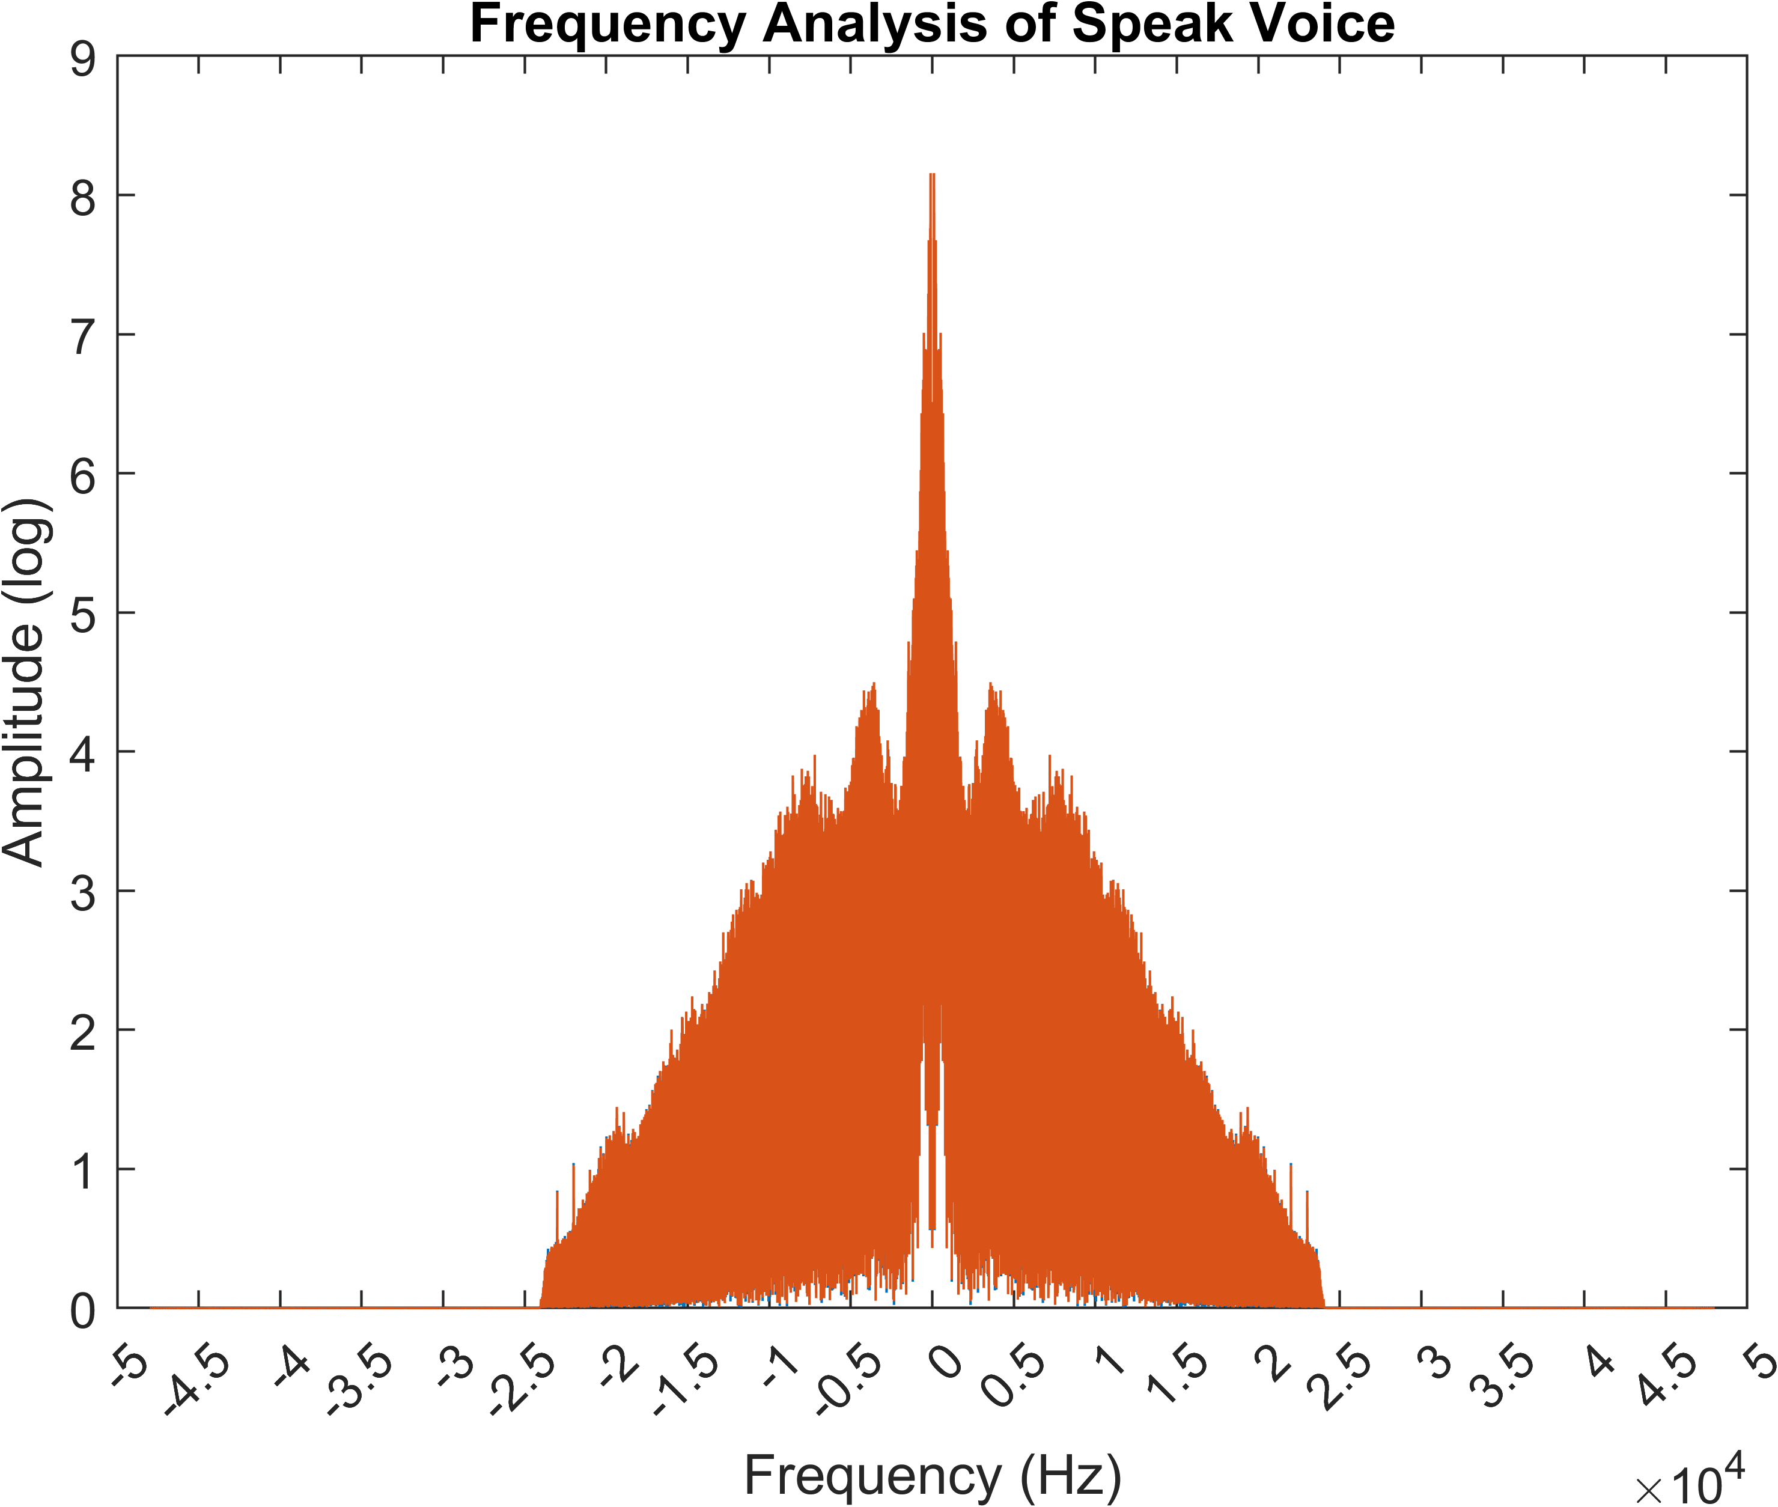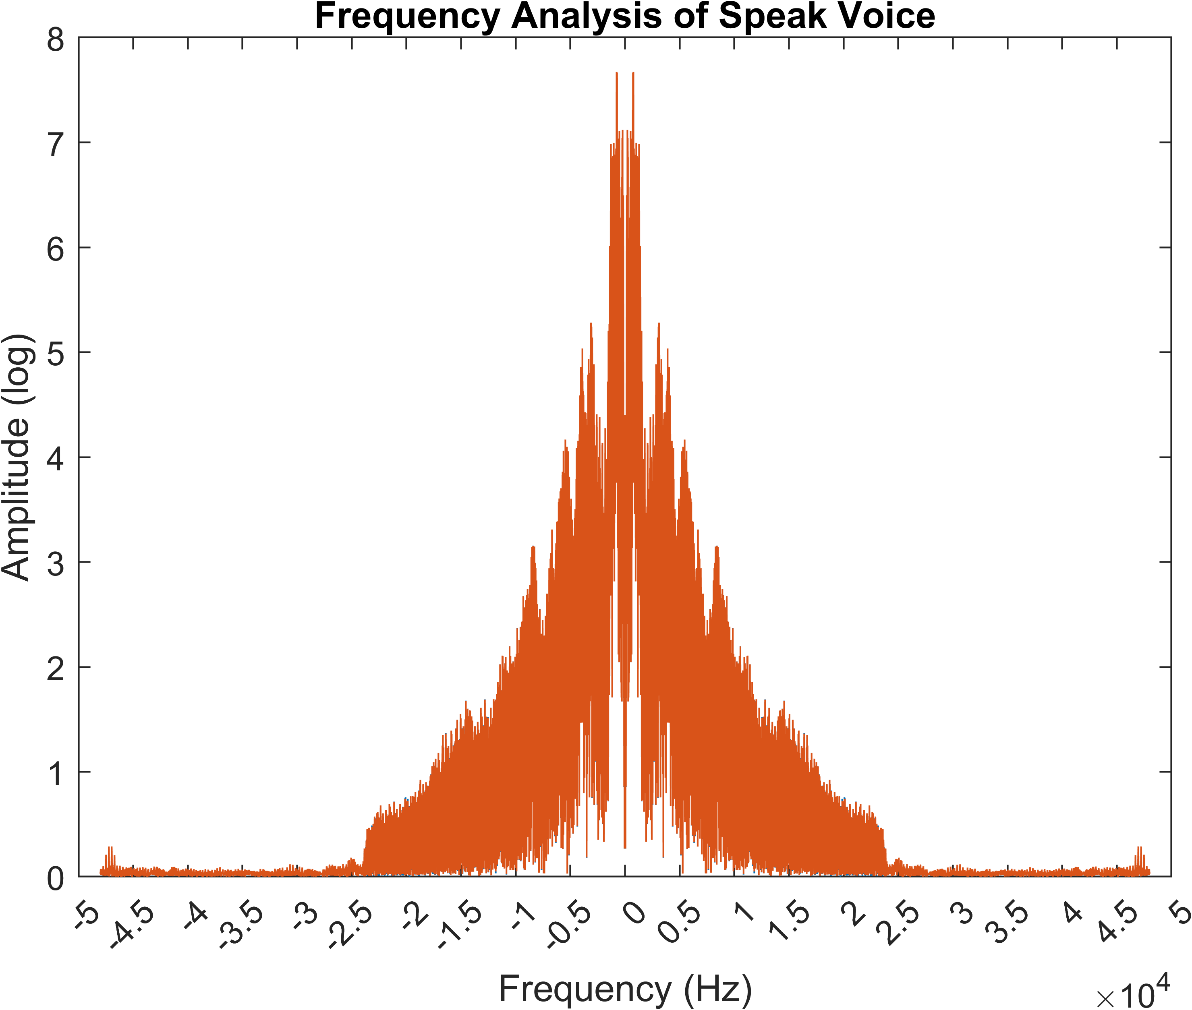

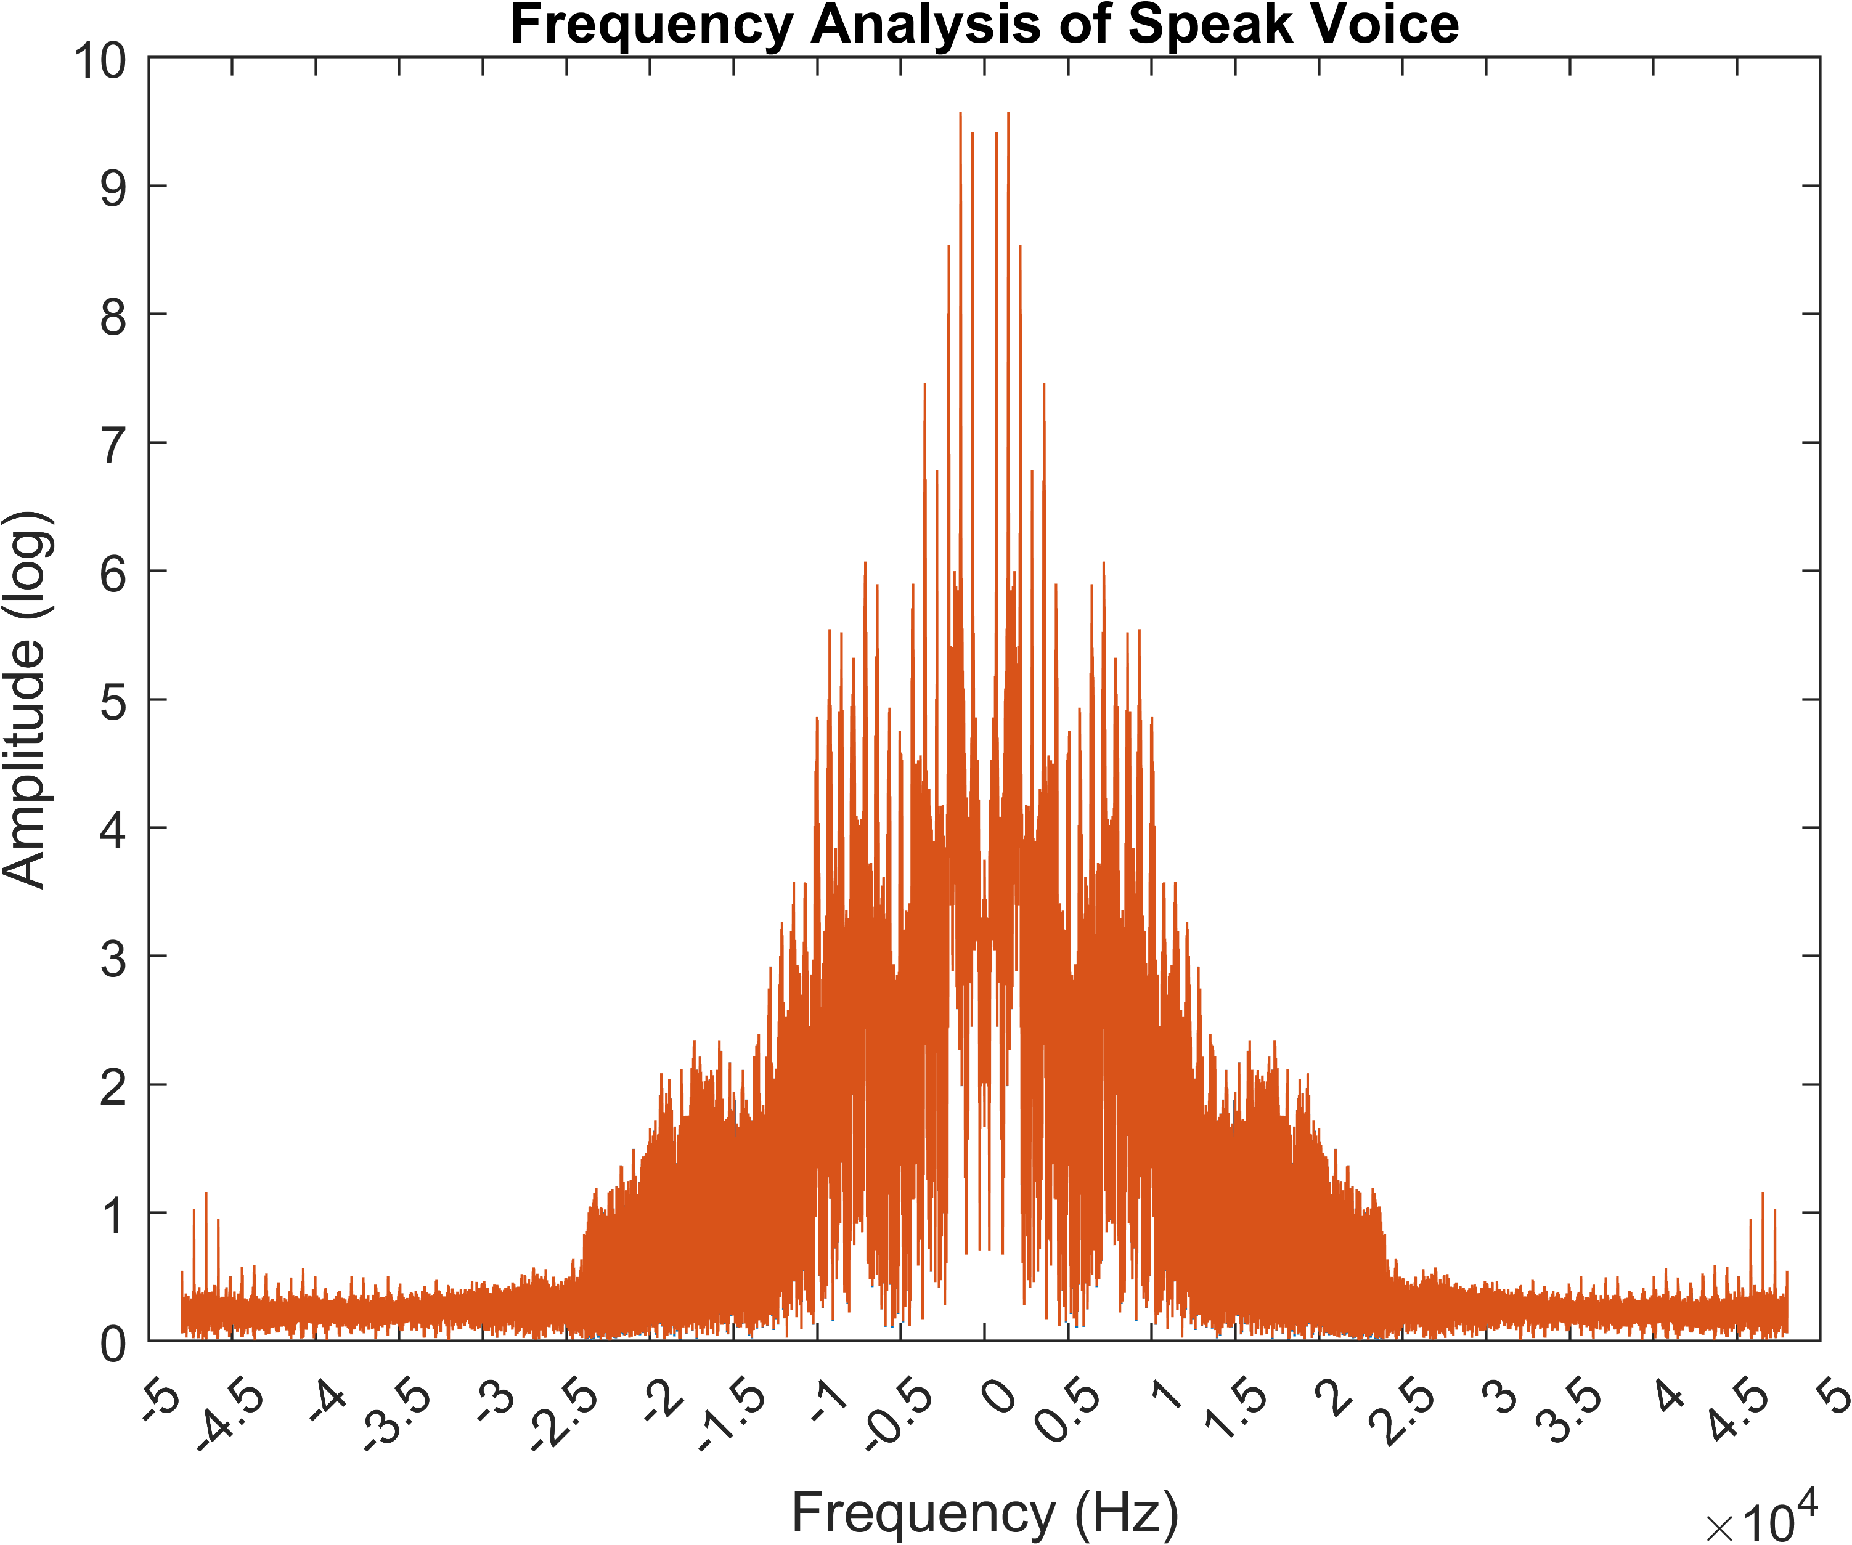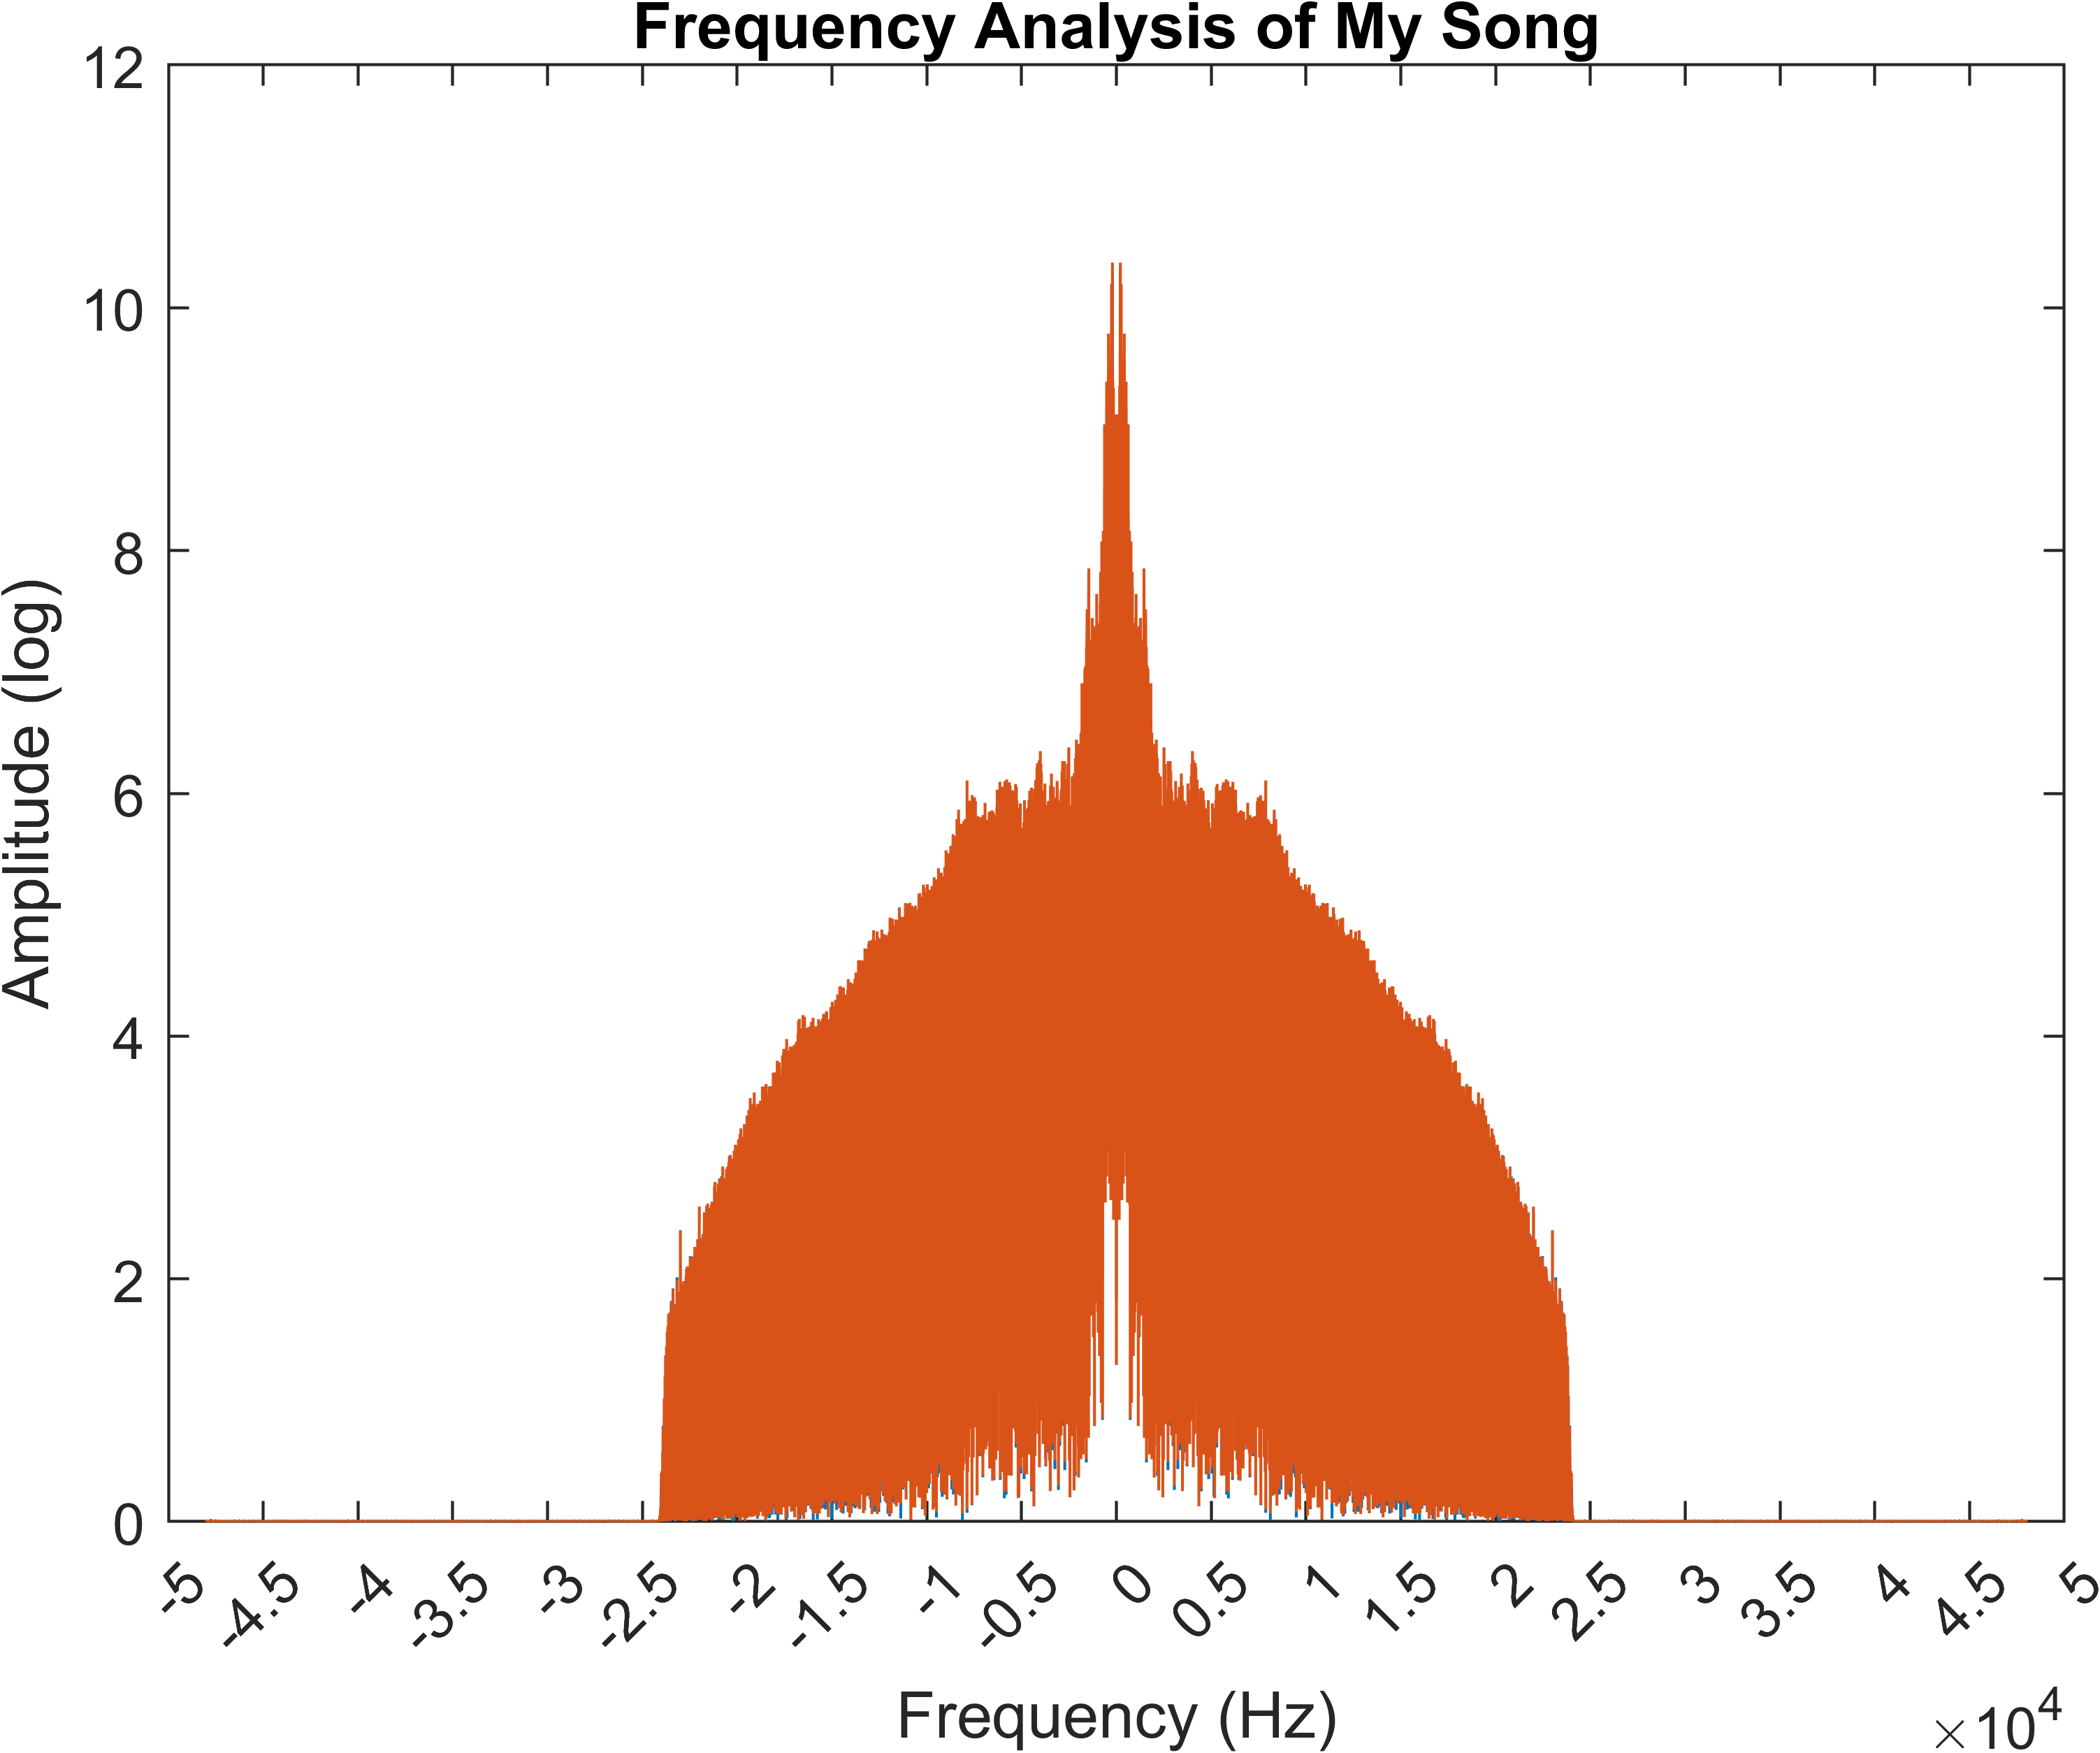

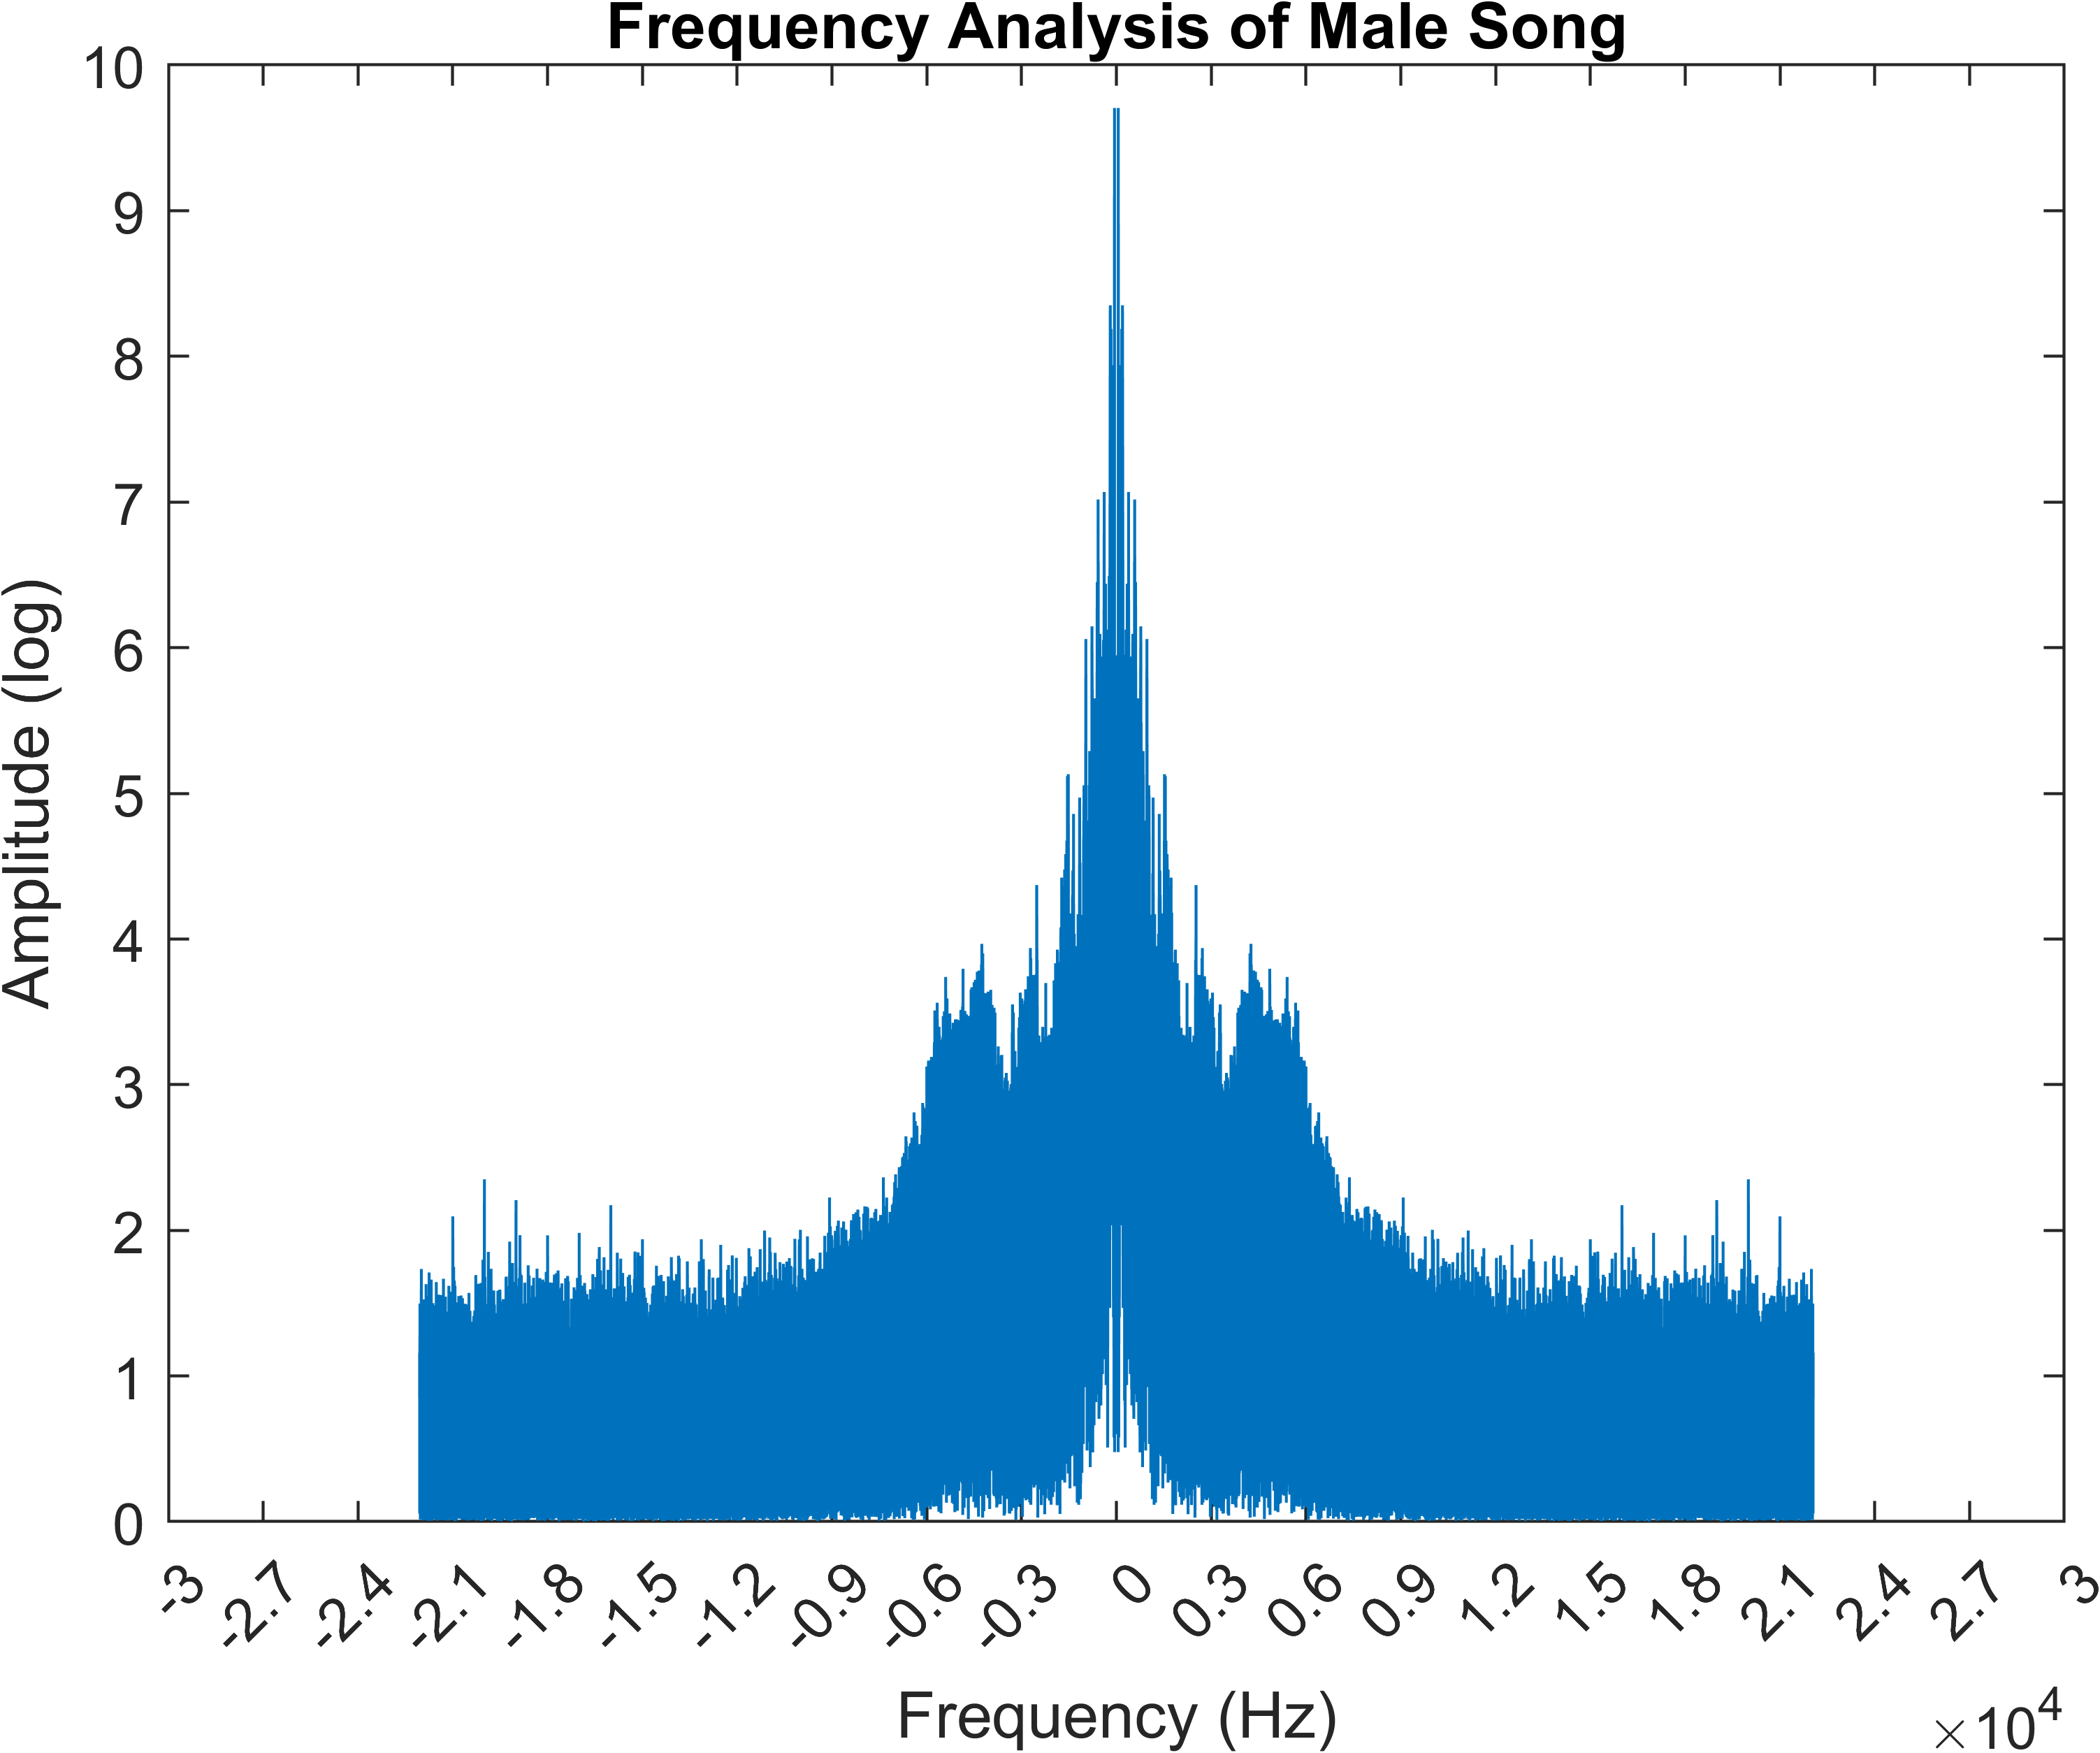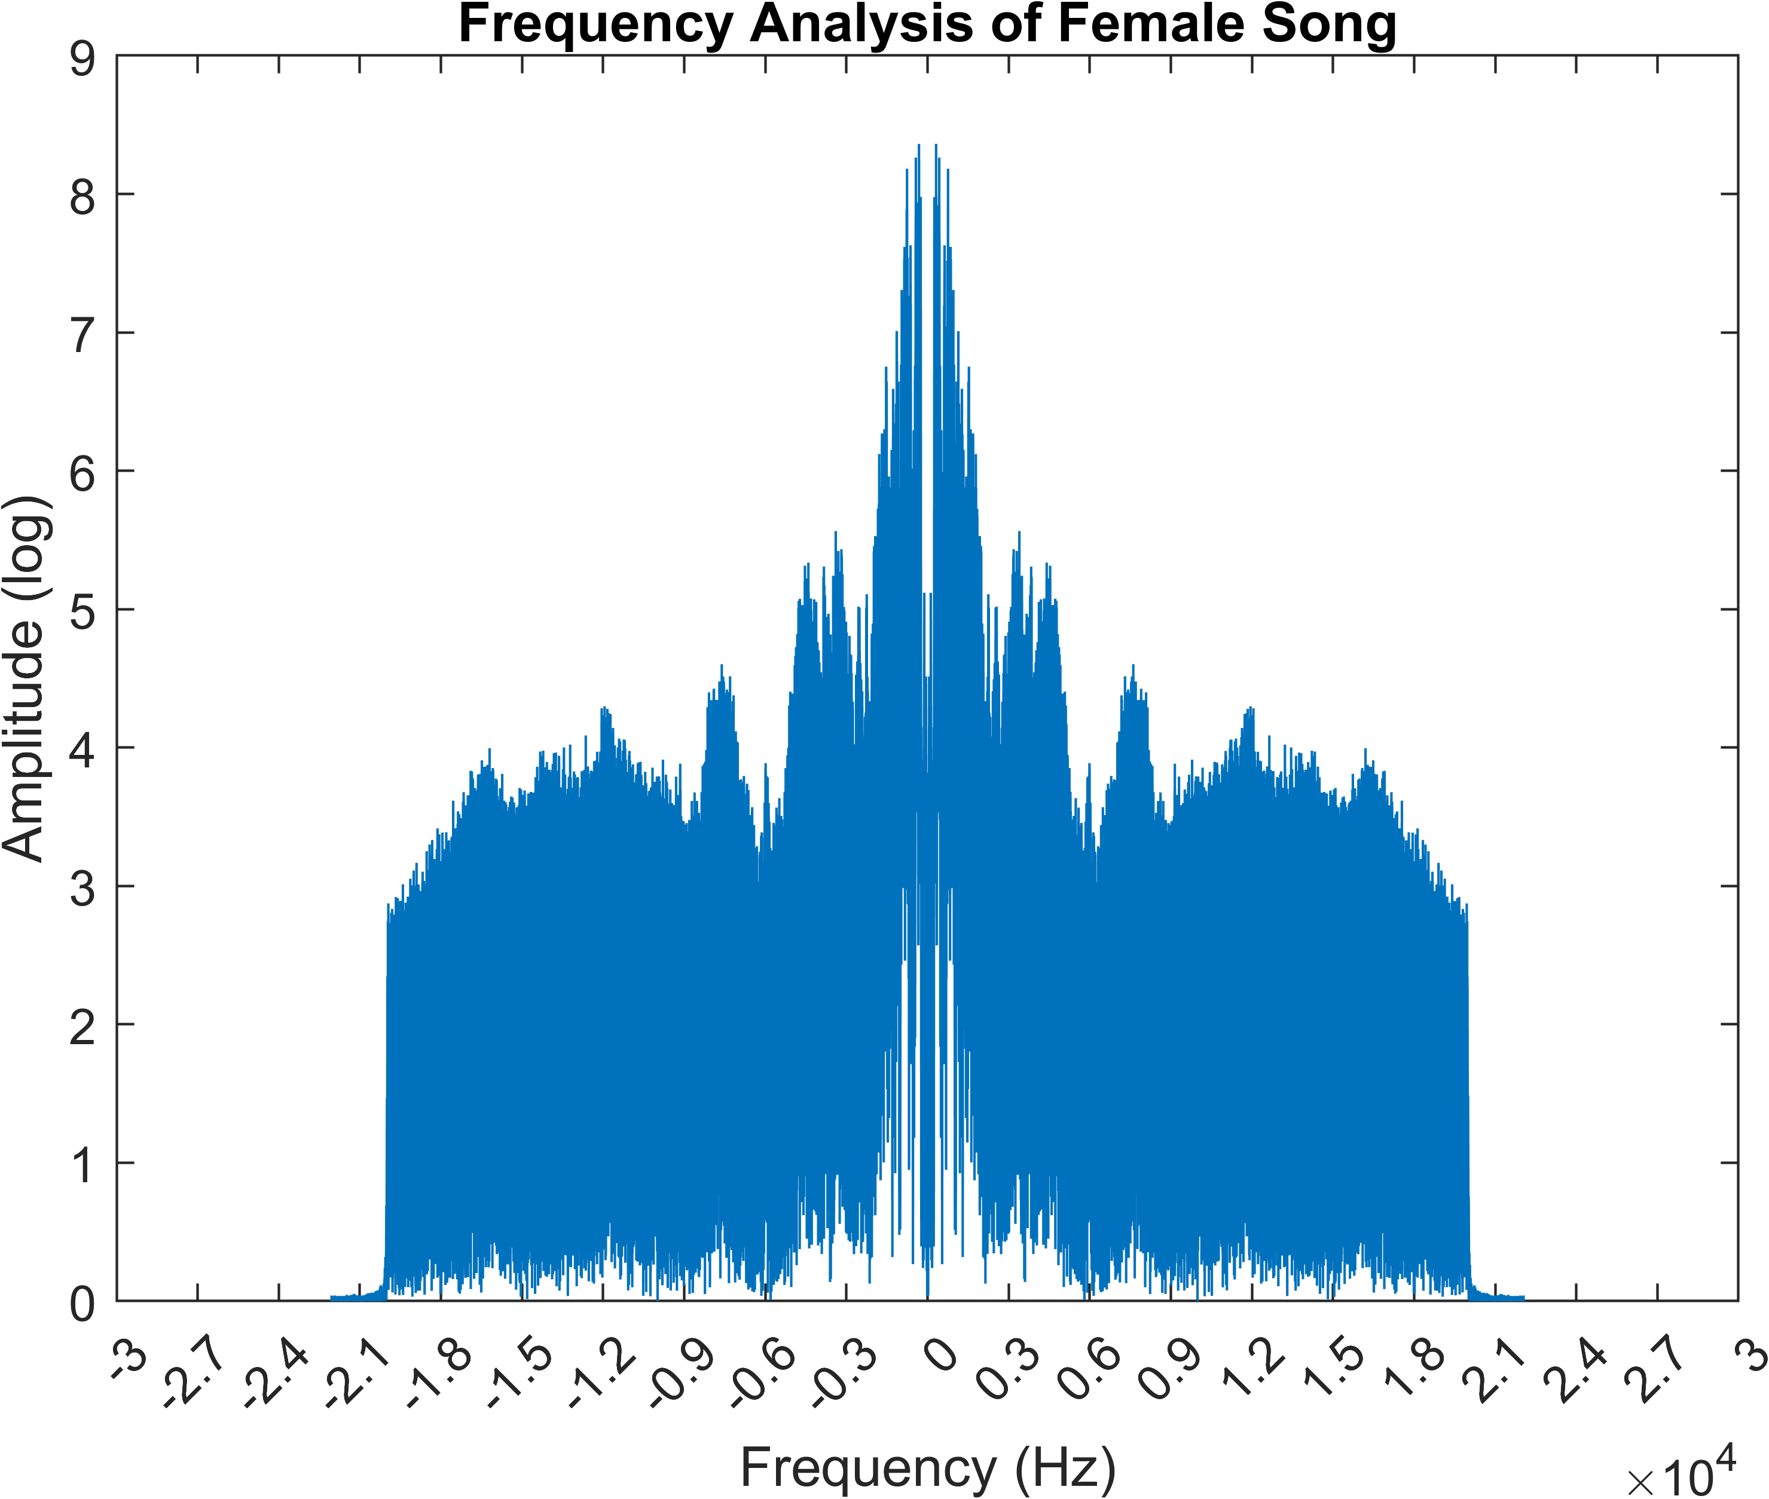

# 語聲、噪聲、歌聲在不同domain中的觀察

* Time domain
  + 尖叫聲顯然較為密集
* Spectrogram
  + 尖叫聲分布最均勻
* Frequency domain
  + 尖叫聲幾乎每種頻率都有分布
  + 女生的聲音分布比男生傾向於高頻率

# Earth Mover’s Distance (EMD)

我一直 out of memory，算不出來

# 分析936Hz - Clear Your Mind _ Healing Tone - Boost Positive Energy - Third Eye Activation _ Solfeggio

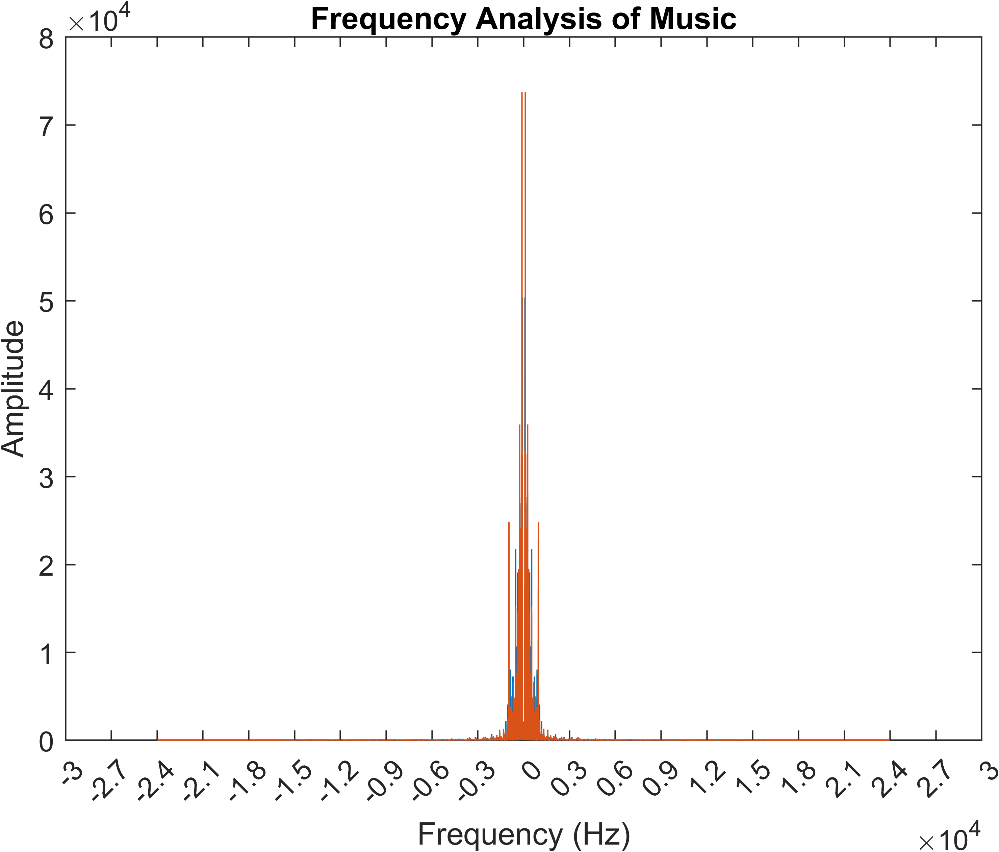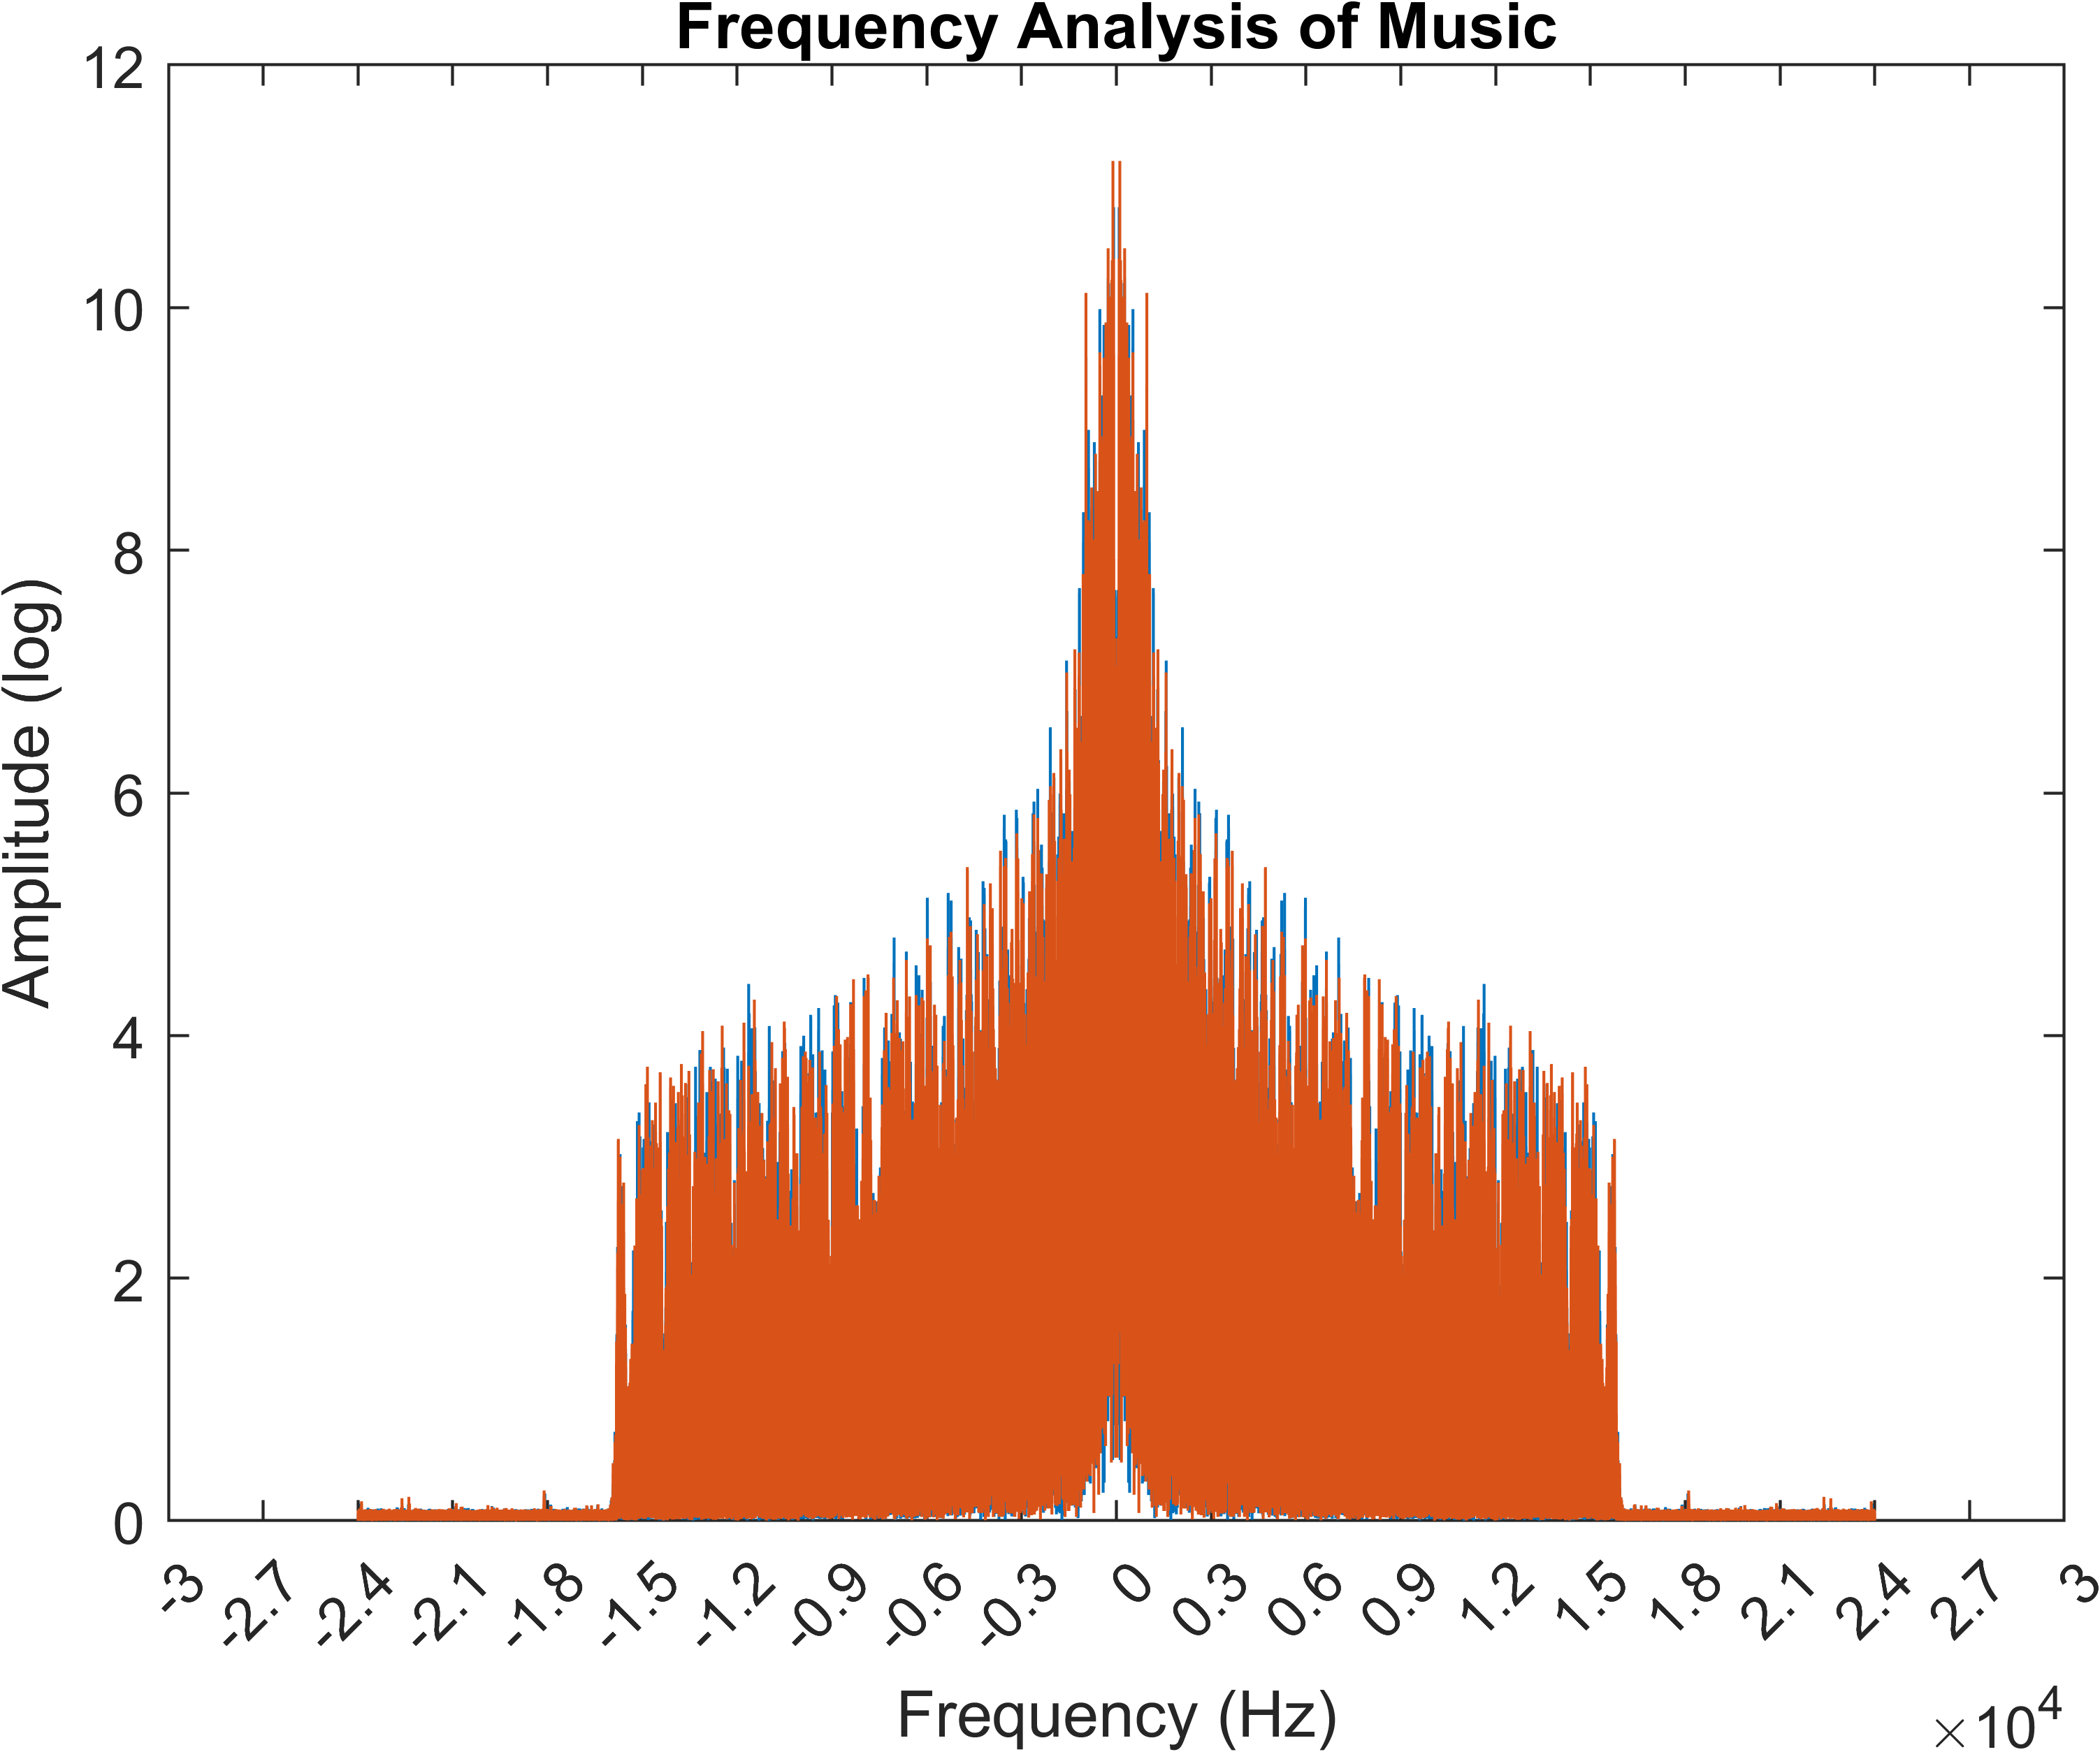

分析結果為，936 Hz 並不是整首音樂的主要成分